THE WORLD OF GENERATIVE AI

YOUR AI CAREER LAUNCHPAD
Build Your Professional Profile
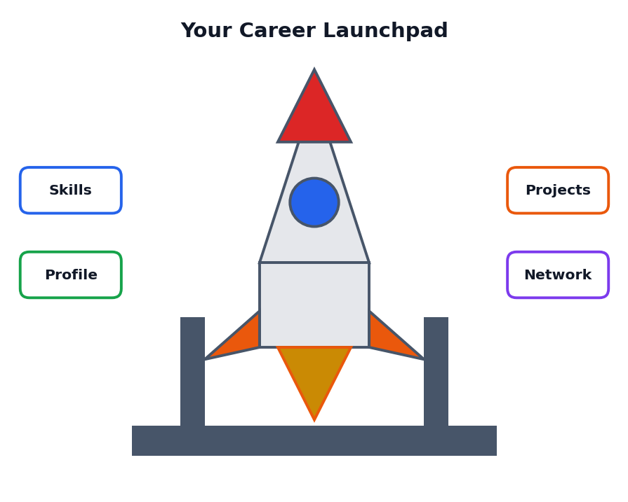
A Student Course Book
Class 12 | One-Month Course
Simple language, real examples, pictures and practice

About This Book
Read this page first
Welcome to Your AI Career Launchpad: Build Your Professional Profile. This book is part of the course The World of Generative AI. A launchpad is the place from which a rocket starts its journey. In the same way, this book helps you prepare for the start of your own career in a world where Artificial Intelligence (AI) is becoming part of almost every kind of work.
You may be wondering: I am still in Class 12. Why should I think about a professional profile now? The answer is simple. The students who begin early, who know their strengths, build useful skills, collect proof of their work and learn to present themselves honestly, have more choices when they finish school. This book shows you how to do all of that, step by step.
Figure 0.1: Skills, profile, projects and network form your launchpad

Who is this book for?
This book is written for Class 12 students. You do not need any work experience or any technical background. All words are explained in simple English, and difficult words are collected in the Glossary at the end.

What will you be able to do after this course?
- Explain the difference between a job and a career, and why AI is changing both.
- Discover your interests, strengths and values using simple self-assessment tools.
- Describe several AI-related careers and the skills each one needs.
- Plan your learning path after Class 12.
- Write a clear, honest one-page resume.
- Create a portfolio of small projects with proof of your work.
- Set up a safe and professional online profile.
- Introduce yourself with confidence and answer interview questions using the STAR method.
- Use AI tools responsibly to improve your profile without cheating.
- Make a 90-day action plan for your future.

How to use this book
- Read one chapter at a time. Each chapter begins with goals and ends with a summary.
- Study every picture, because pictures explain ideas quickly.
- Do all the Activity boxes. Your profile will be built from your own answers.
- Keep a notebook called My Launchpad File where you collect all your work.
- Finish the practice questions in Chapter 18 and the final project in Chapter 17.

What the coloured boxes mean
KEY IDEA
A big idea to remember for exams and for real life.

TIP
A helpful shortcut or good habit.

CAREFUL
A common mistake or a risk to avoid.

EXAMPLE
A sample that shows the idea at work. Names of people and organisations in examples are imaginary.

ACTIVITY
A task for you to do, alone or with friends.

IMPORTANT NOTE
Courses, rules, fees and job requirements change from time to time. Always check the latest details from official sources, your school counsellor or your teachers before making decisions.

Contents
What you will find in this book
Chapter | Title | What you will learn
1 | Why Plan a Career Now? | Job and career, the changing world of work, the launchpad idea
2 | Know Yourself | Interests, strengths, values, skills inventory
3 | Exploring AI Careers | Roles, tasks and skills in the world of AI
4 | Skills for the AI Age | Human skills, digital skills, specialist skills, T-shape
5 | Education Pathways After Class 12 | Degrees, diplomas, online learning, choosing wisely
6 | Your Professional Profile: The Big Picture | Six parts of a profile and how they connect
7 | Writing a Great Resume | Sections, action words, examples, mistakes
8 | Building Your Portfolio | Projects, case studies, proof of work
9 | Your Online Presence | Professional profile, digital footprint, privacy
10 | Personal Brand and Communication | Self-introduction, emails, speaking, listening
11 | Using AI to Build Your Profile | Safe and honest ways to use AI, sample prompts
12 | Networking and Mentors | Building relationships, messages, informational talks
13 | Applications and Interviews | Forms, tests, STAR method, group discussion
14 | Your Learning Plan and Goals | SMART goals, goal ladder, 90-day plan, habits
15 | Gaining Experience Early | Internships, volunteering, competitions, projects
16 | Professional Ethics and Online Safety | Honesty, respect, privacy, spotting scams
17 | Case Studies and Final Project | Five students' stories and your Profile Kit
18 | Practice Questions | MCQs, short and long answers, answer key
19 | One-Month Learning Plan | Weekly schedule and assessment ideas
 | Glossary and Quick Revision | Key words and one-page summary

CHAPTER 1

Why Plan a Career Now?
Understanding jobs, careers and a world that is changing with AI
CHAPTER GOALS
- Understand the difference between a job and a career.
- See how AI is changing the world of work.
- Learn why early preparation gives you more choices.
- Understand the idea of a career launchpad.

1.1 Job and Career: What Is the Difference?
A job is a particular piece of work that you do for pay, such as working as a shop assistant, a clerk or a teacher in a school. A career is the long journey of your working life. It includes all your jobs, your learning, your experiences and the skills you build over many years.
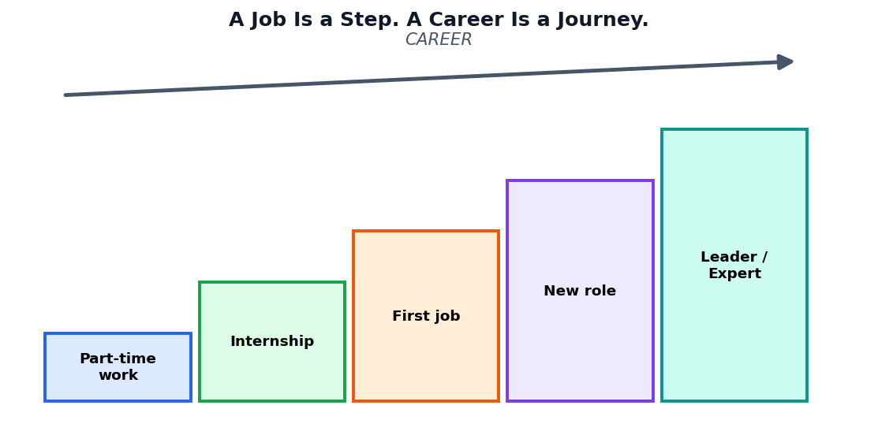
Figure 1.1: A job is one step; a career is the whole journey
Job | Career
One position in one place | A series of positions over many years
Mainly about earning a salary | About growth, learning, purpose and earning
Can end suddenly | Continues even when jobs change
Needs skills for today | Needs skills for today and tomorrow

1.2 The Changing World of Work
Think about how your parents or grandparents studied and worked. Many people once stayed in one job for 30 years. Today, technology changes quickly. New tools appear, some tasks become automatic and new kinds of jobs are created. AI is one of the biggest reasons for this change.

What is changing?
- Tasks are changing. AI can now help with writing, designing, calculating, translating and answering questions.
- Skills are changing. People need to learn new tools many times in their lives.
- New roles are appearing. Jobs that did not exist earlier, such as data analyst or AI solution designer, are now common.
- Every field is affected. Doctors, farmers, teachers, artists, engineers and shopkeepers can all use AI as an assistant.
KEY IDEA
AI is unlikely to remove the need for people. But people who know how to work well with AI will have an advantage over those who do not.

1.3 Why Start Early?
- More choices. When you know yourself and your options, you can pick courses and activities that fit you.
- More time to learn. Skills grow slowly. Starting early gives you time to practise.
- Less fear. A plan makes the future feel clearer and less frightening.
- Better first impression. When you apply for a course, an internship or a job, a ready profile makes you stand out.
- Confidence. Seeing your own projects and skills gives you self-belief.

1.4 What Is a Professional Profile?
A professional profile is the complete picture of who you are as a learner and a future worker. It includes your skills, your education, your projects, your achievements, your resume, your online presence and the way you present yourself. It is not only a document; it is a story told with proof.
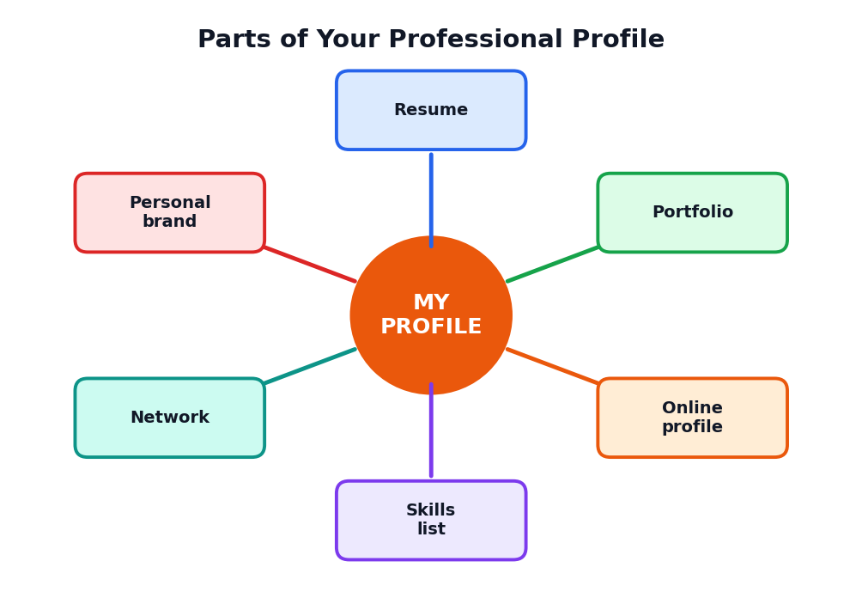
Figure 1.2: Six parts of a professional profile
Do not worry if your profile looks small today. Everyone starts with a few lines. This book will help you to grow it, one small step at a time.

1.5 The Launchpad Idea
A rocket cannot reach space without a strong launchpad. The launchpad holds the rocket steady, provides support and gives a safe start. Your launchpad is made of four supports:
Support | Meaning | Chapters
Skills | What you can do: human, digital and specialist skills | 2, 3, 4, 5
Profile | How you present yourself: resume, online page, pitch | 6, 7, 9, 10
Projects | Proof of your work: portfolio and experience | 8, 15
Network | People who guide and support you: mentors, friends, communities | 12

TIP
Do not wait until you feel perfectly ready. Launch small, learn from feedback and improve.

1.6 Three Myths About Careers
Myth | Truth
I must choose one career for my whole life now. | Most people change direction several times. Choose a good first step.
Only students with top marks will succeed. | Marks matter, but skills, projects, attitude and effort matter too.
AI careers are only for computer geniuses. | Many roles in the AI world need communication, ethics, design, domain knowledge and care for people.

ACTIVITY 1.1: CAREER CONVERSATION
Interview one adult you trust about their work. Ask: (1) How did you choose this work? (2) What skills do you use most? (3) How has technology changed your work? (4) What advice would you give a Class 12 student? Write a half-page note in your Launchpad File.

1.7 Chapter Summary
- A job is one step; a career is the long journey.
- AI is changing tasks, skills and roles in nearly every field.
- Starting early gives more choices, time, confidence and a stronger first impression.
- A professional profile has six parts: resume, portfolio, online profile, skills list, network and personal brand.
- Your launchpad stands on skills, profile, projects and network.
CHAPTER 2

Know Yourself
The first step of every good career plan is to understand yourself
CHAPTER GOALS
- Discover your interests, strengths and values.
- Understand the career sweet spot.
- Make a personal skills inventory.
- Use AI and people around you to gain new views about yourself.

2.1 Why Self-Knowledge Matters
Before choosing a path, you must know the person who will walk on it. If you choose a career only because friends chose it or because it sounds impressive, you may become unhappy later. If you choose a path that matches your interests, strengths and values, your work will feel more meaningful and you will keep improving.

2.2 The Career Sweet Spot
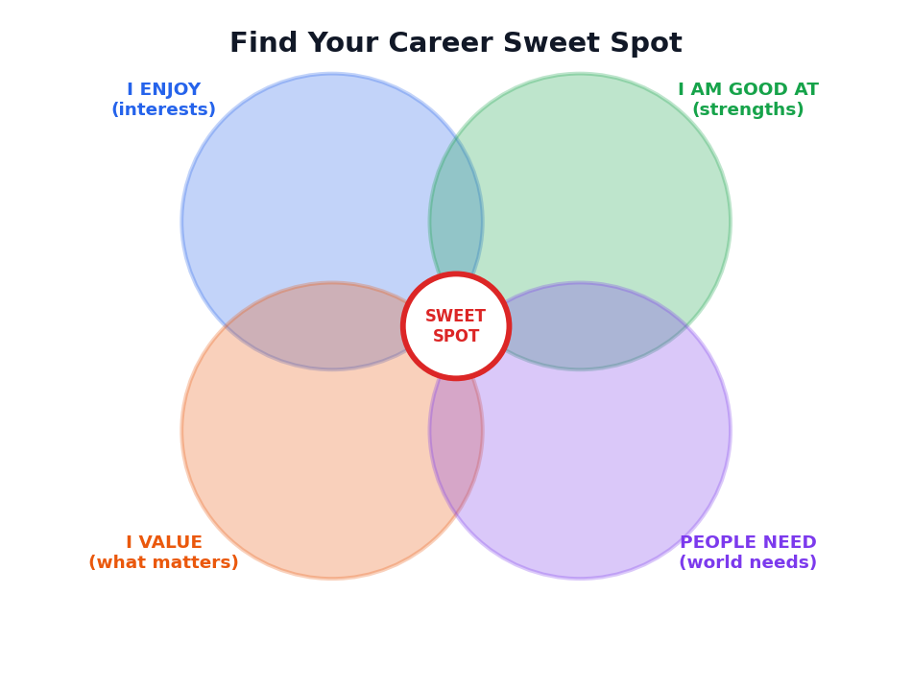
Figure 2.1: The sweet spot is where four circles overlap
Circle | Question to ask yourself
I enjoy (interests) | What activities make me lose track of time? What do I read, watch or talk about happily?
I am good at (strengths) | What do teachers and friends say I do well? What comes easily to me?
I value (what matters) | What is important to me: helping people, creativity, money, security, freedom, adventure?
People need (world needs) | What problems around me need solving? Where do people need help?

You may not find a perfect career where all four circles meet. But the more circles you cover, the more satisfying your career is likely to be.

2.3 Your Interests
Interests are the things you like to do or learn about. Here is a simple list of interest areas. Tick the ones that attract you.
Area | Examples of activities | Tick
Science and technology | Experiments, coding, robots, gadgets, data
Helping and caring | Teaching, health care, counselling, volunteering
Creative and design | Drawing, writing, music, video, fashion
Business and leadership | Organising events, selling, planning, leading teams
Nature and environment | Farming, animals, weather, sustainability
Law, society and public service | Debate, civics, social issues, administration
Building and fixing | Machines, electricals, construction, repairing

2.4 Your Strengths
A strength is something you can do well, or learn quickly. Strengths can be thinking strengths (like solving puzzles), people strengths (like explaining or leading), or practical strengths (like drawing or building).
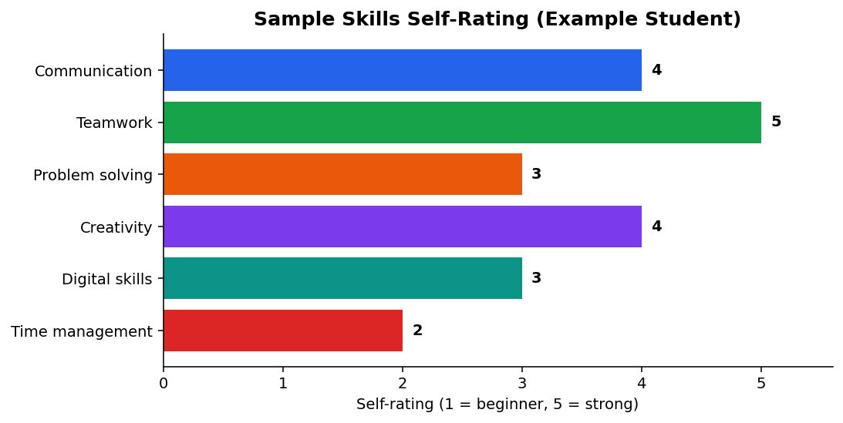
Figure 2.2: A sample self-rating chart for six skills. Make your own!
TIP: ASK OTHERS
We often cannot see our own strengths. Ask three people (a teacher, a friend, a family member): 'What do you think I am good at?' Note common answers.

2.5 Your Values
Values are the things that matter most to you. They guide your choices. Look at this list and choose your top five.
Value | Meaning
Helping others | Making life better for people
Creativity | Making new and original things
Security | Having stable, steady income and life
Learning | Always discovering new things
Independence | Making your own decisions
Teamwork | Working closely with others
Adventure | Trying new places and challenges
Honesty | Being truthful and fair
Recognition | Being respected for your work
Balance | Time for family, health and hobbies

2.6 Your Personal Skills Inventory
A skills inventory is a list of everything you can do. Many students think they have no skills, but when they look carefully, they find many. Use three groups.
Skill group | Examples | My examples
Human skills | Communication, teamwork, leadership, empathy, time management
Digital skills | Typing, spreadsheets, presentations, internet research, using AI tools
Subject and special skills | Maths, biology, accounts, drawing, a language, sports, a musical instrument

EXAMPLE: MEENA'S SKILLS INVENTORY
Human: leads her class cultural team; explains maths to juniors. Digital: makes slides; uses spreadsheets for class marks. Special: knows Tamil and English well; draws neat diagrams; learned basic Python from a free online course.

2.7 Personality and Working Style (Handle with Care)
Some people like to work alone; others prefer teams. Some like clear rules; others like freedom. Some enjoy talking to many people; others like quiet, deep work. Online personality quizzes can give ideas, but they are not exact science. Use them only as starting points for thinking, never as final labels about who you are.
CAREFUL
Do not let any quiz, test or AI tool decide your future. Use the results as a mirror to think, then talk with teachers, parents and counsellors.

2.8 Using AI for Self-Reflection
AI can act as a thinking partner. It can ask you questions that help you reflect. You must give honest answers, and you must not share private or sensitive details.
SAMPLE PROMPT
"Act as a friendly school career counsellor. I am a Class 12 student. Ask me one question at a time about my interests, strengths and values. After 8 questions, summarise what you noticed in a short list. Do not suggest final careers yet."

ACTIVITY 2.1: MY SWEET SPOT
In your Launchpad File draw the four circles of Figure 2.1. Write three items in each circle. Then circle any items that appear in more than one place. Finally write two sentences: 'The kind of work that may suit me is ... because ...'.

2.9 Chapter Summary
- Self-knowledge is the base of a good career plan.
- The career sweet spot joins interests, strengths, values and world needs.
- A skills inventory lists human, digital and special skills.
- Quizzes and AI can help you reflect, but your own thinking and real conversations matter more.
CHAPTER 3

Exploring AI Careers
Roles, tasks and skills in the world of Artificial Intelligence
CHAPTER GOALS
- Learn about different kinds of AI-related careers.
- Understand what people in each role actually do.
- See that AI careers are open to many types of learners.
- Learn how to research a career properly.

3.1 Two Kinds of AI Careers
When people hear 'AI career', they often imagine only programmers. In reality there are two big groups of careers.
Group | Meaning | Examples
AI-building careers | People who create, train, test and look after AI systems | Data engineer, machine learning engineer, AI researcher
AI-using careers | People in any field who use AI to do their work better | Doctor, teacher, farmer, designer, accountant, journalist, lawyer who use AI tools wisely

Most people in the future will belong to the second group. Even if you never build an AI model, knowing how to use it responsibly will be an important skill.

3.2 A Map of AI-Related Careers
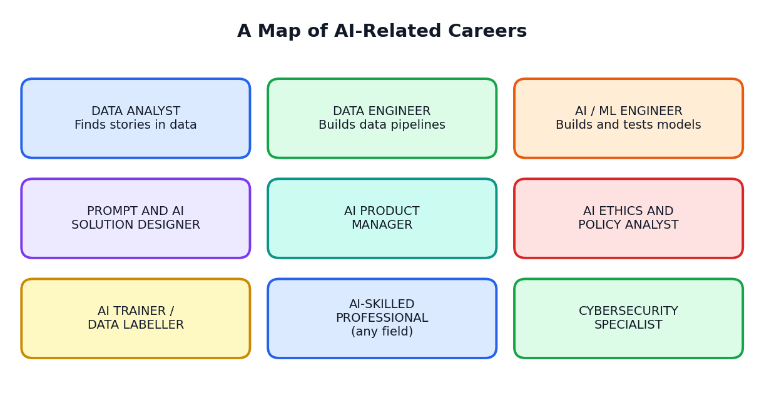
Figure 3.1: Some careers in the world of AI

3.3 Roles Explained in Simple Words
Role | What the person does | Useful skills
Data analyst | Collects and studies data to answer questions, and explains findings with charts | Maths and statistics sense, spreadsheets, clear communication
Data engineer | Builds the systems that collect, store and move data safely | Programming, databases, careful working
Machine learning (ML) engineer | Builds, tests and improves AI models | Programming, maths, problem solving
AI solution designer / prompt designer | Designs how people use AI tools for a task; writes and tests instructions | Language skills, logic, understanding users
AI product manager | Decides what AI product to build and guides the team | Communication, planning, understanding customers
AI ethics and policy analyst | Checks that AI is fair, safe, private and legal | Critical thinking, law and social awareness
AI trainer / data labeller | Checks and labels examples so that AI can learn properly | Attention to detail, subject knowledge
Cybersecurity specialist | Protects systems and data from attacks | Technical skills, alertness, honesty
AI-skilled professional in any field | Uses AI tools to improve work in health, farming, teaching, business, art and more | Subject knowledge plus AI literacy

IMPORTANT NOTE
Names of roles keep changing. Companies may use different titles for similar work. Focus on the tasks and skills, not just the title.

3.4 A Day in the Life: Imaginary Examples
DATA ANALYST AT A RETAIL COMPANY (IMAGINARY)
Priya starts her day by checking last week's sales data. She cleans the data, makes a chart showing which products sell during festivals, and explains to the store manager why stock should be increased. She spends part of the day in meetings and part on spreadsheets and data tools.

AI SOLUTION DESIGNER AT A CLINIC (IMAGINARY)
Arun talks with nurses to learn which paperwork takes too much time. He designs a tool that drafts appointment reminders. He tests it with sample messages, fixes mistakes and trains the staff. He often checks with doctors that nothing unsafe is written.

FARMER USING AI ADVICE (IMAGINARY)
Kavitha runs a small farm. She uses a voice-based tool in her language to check weather advice and spot plant diseases from photos. She still decides with her own experience and talks to local experts when something looks unusual.

3.5 AI Careers Are Not Only for Computer Experts
Many different kinds of people work with AI. Writers help to improve language tools. Teachers help to design learning apps. Doctors guide health tools. Artists and designers work on creative tools. Lawyers and social scientists work on rules and fairness. This means that whatever your interest, there may be a way to connect it with AI.
If you like... | You could explore...
Maths and logic | Data analysis, machine learning, AI research
Languages and writing | Prompt design, content with AI, language tools, translation
Biology and health | Health data, medical AI support, bioinformatics
Design and art | AI-supported design, animation, user experience
Business and leadership | AI product management, entrepreneurship, consulting
Law, ethics and society | AI policy, ethics review, data protection
Teaching | Educational technology, learning design, AI tutoring support

3.6 How to Research a Career
- Read reliable descriptions of the role from official and trusted sources.
- Watch or listen to talks by people working in the field.
- Talk to at least two people who do the work.
- Try a small project or free course to taste the work.
- List the education and skills the role needs.
- Check how the role may change in the future.
ACTIVITY 3.1: CAREER RESEARCH SHEET
Choose two careers from Figure 3.1. For each, make a table with: What the person does, Skills needed, Education path, What I like, What worries me. Compare your two tables and write which one you want to explore further, and why.

3.7 Chapter Summary
- AI careers include AI-building roles and AI-using roles; most people will be AI users in their own fields.
- Roles include data analyst, data engineer, ML engineer, solution designer, product manager, ethics analyst and more.
- Many AI careers need communication, domain knowledge and ethics, not only coding.
- Research careers by reading, listening, talking to people and trying small projects.
CHAPTER 4

Skills for the AI Age
Human skills, digital skills and special skills that make you valuable
CHAPTER GOALS
- Understand the three layers of skills.
- Learn what a T-shaped skill profile means.
- Know how to learn a new skill step by step.
- Start building skills from today.

4.1 The Skills Pyramid
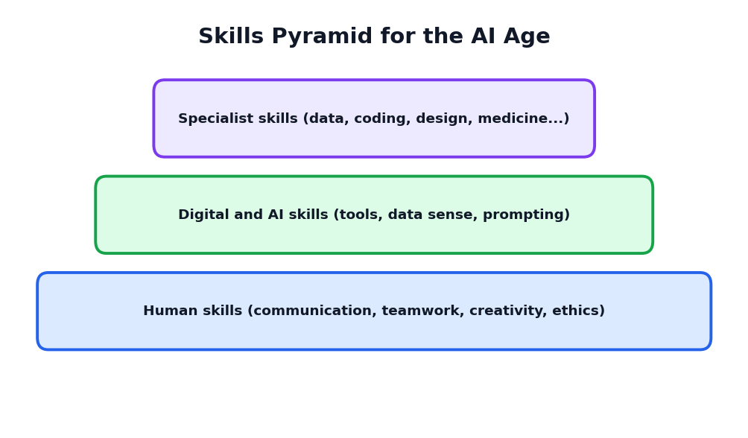
Figure 4.1: Three layers of skills for the AI age

4.2 Layer 1: Human Skills
Human skills are the base of the pyramid. They are valuable in every job and are hard for machines to copy completely.
Skill | Meaning | How to practise
Communication | Speaking, writing and listening clearly | Give class talks, write short essays, practise active listening
Teamwork | Working well with others to reach a goal | Join group projects, sports or clubs
Critical thinking | Questioning, checking and judging information | Verify facts, compare two sources, ask 'why?'
Creativity | Finding new ideas and solutions | Brainstorm, draw, invent, solve puzzles
Empathy | Understanding other people's feelings | Listen without interrupting; volunteer
Time management | Using time wisely | Make weekly plans; use a calendar
Adaptability | Adjusting to change | Try new tools and activities
Leadership | Guiding and motivating others | Lead a small project or event

4.3 Layer 2: Digital and AI Skills
- Basic computer skills: typing, files and folders, email, safe browsing.
- Office tools: documents, spreadsheets and presentations.
- Information skills: searching, comparing and judging sources.
- Data sense: reading tables and charts; asking what the numbers mean.
- AI literacy: knowing what AI can and cannot do, writing good prompts, checking outputs, protecting privacy.
- Cyber safety: strong passwords, spotting scams, protecting personal data.
TIP
A spreadsheet is one of the best first tools to learn. It teaches you about data, logic and organising information, all of which are useful for AI.

4.4 Layer 3: Specialist Skills
These are skills for a particular field: coding for software roles, anatomy for medicine, accounting for finance, design tools for creative work, and so on. You will build these skills mainly through your higher education, practice and projects.

4.5 T-Shaped Skills
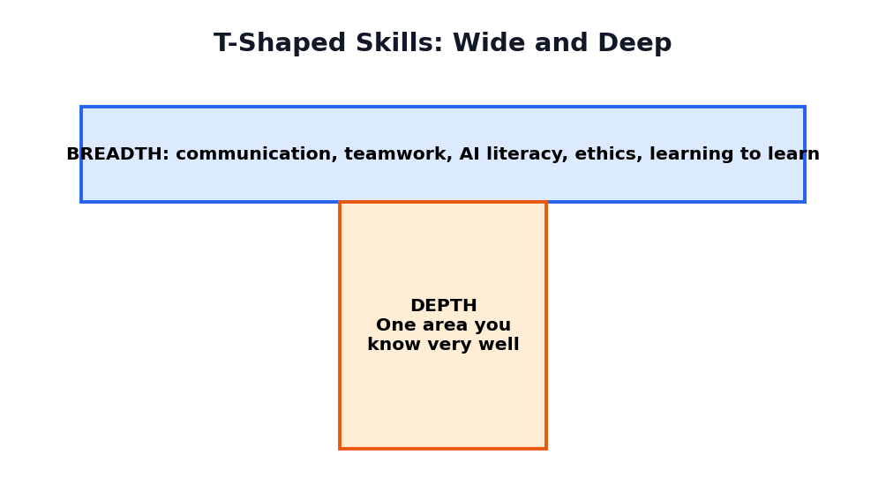
Figure 4.2: Broad skills across the top; deep skill in one area
A T-shaped person has breadth (many useful general skills) and depth (one area of strong expertise). Employers like T-shaped people because they can work with many types of colleagues and still contribute special knowledge.
EXAMPLE
Divya wants to work in health technology. Her depth: biology and basic data analysis. Her breadth: clear communication, teamwork, using AI tools safely, presenting to others.

4.6 How to Learn a New Skill
- Choose one skill at a time and write why you want it.
- Find a good learning source: a teacher, a book or a trusted online course.
- Learn the basics first in short, regular sessions (20 to 30 minutes daily is better than 5 hours once a month).
- Practise with a small project right away.
- Get feedback from a teacher, mentor or friend.
- Record your progress in your Launchpad File.
- Teach someone else. Explaining a skill is the best way to master it.

4.7 Growth Mindset
A growth mindset is the belief that skills can be developed through effort, practice and good feedback. A person with a growth mindset says, 'I cannot do this yet', rather than 'I cannot do this'. This attitude is perhaps the most important skill of the AI age because you will keep learning new tools throughout your life.
Fixed mindset thinking | Growth mindset thinking
I am not good at maths. | I am not good at maths yet. What can I practise?
I made a mistake, so I am a failure. | A mistake shows me what to learn next.
Feedback hurts me. | Feedback helps me improve.
Others' success makes me jealous. | Others' success shows me what is possible.

ACTIVITY 4.1: MY SKILLS GAP
Choose a career you are interested in. List ten skills it needs. Mark each as 'I have it', 'I am learning it' or 'I need to start'. Pick two skills to start in the next month and write how you will practise them.

4.8 Chapter Summary
- Three layers of skills: human, digital and AI, and specialist skills.
- Human skills are the strong base for every career.
- T-shaped people have wide general skills and deep skill in one area.
- Learn by choosing one skill, practising with projects and getting feedback.
- A growth mindset keeps you learning throughout life.
CHAPTER 5

Education Pathways After Class 12
Many roads lead to a good career; learn how to choose wisely
CHAPTER GOALS
- Know the main pathways after Class 12.
- Learn how to compare courses.
- Understand the role of online learning and certificates.
- Make a simple decision using a scoring table.

IMPORTANT NOTE
This chapter explains general ideas. Admission rules, courses, entrance exams and fees change. Always confirm details with official websites, your school counsellor and the institutions themselves.

5.1 Many Roads After Class 12
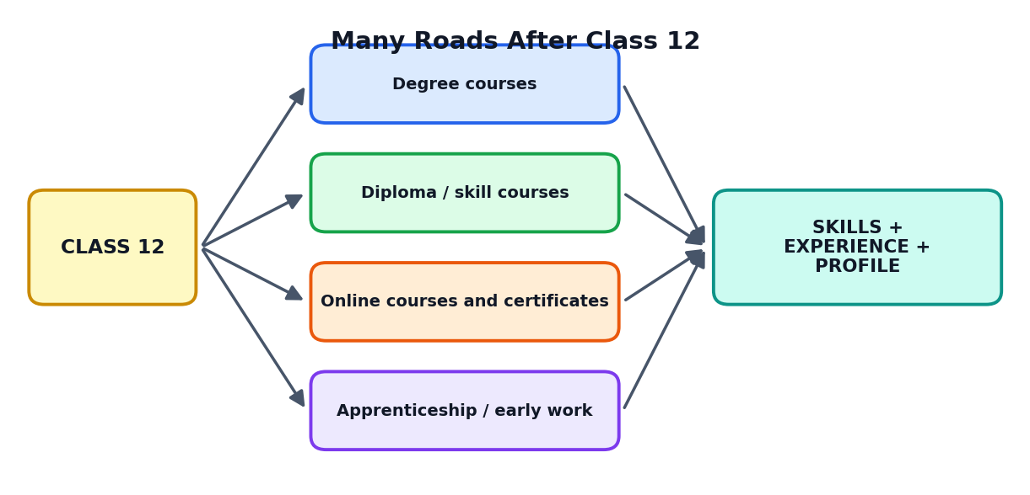
Figure 5.1: Different pathways lead to skills, experience and a profile
Pathway | What it means | Good for people who...
Degree courses | Longer programmes at colleges and universities in many subjects | Want deep knowledge and wide career options
Diploma and certificate courses | Shorter, skill-focused programmes | Want practical skills sooner
Online courses and certificates | Flexible learning from trusted platforms and institutions | Want to add skills alongside studies
Apprenticeship or early work | Learning on the job with guidance | Learn best by doing, or need to earn early
Entrepreneurship | Starting your own small venture, often while learning | Have a strong idea and a willingness to take risks

5.2 Examples of Fields Connected with AI
- Computer science and information technology: the core of building AI systems.
- Mathematics, statistics and data science: understanding data and models.
- Electronics and robotics: machines that sense and act.
- Biology, medicine and health sciences: AI in diagnosis support, drug research and health data.
- Commerce, economics and management: AI in business, finance and planning.
- Design, media and languages: AI in creative work, communication and translation.
- Agriculture and environment: AI in farming, weather and resource planning.
- Law, social science and public policy: rules, ethics and effects of AI on society.

5.3 How to Compare Courses and Colleges
Question | Why it matters
What will I learn in each year? | Check that the subjects match your interests
Are there projects, labs and internships? | Practical experience builds your profile
Who are the teachers and mentors? | Good guidance speeds up learning
What happens to students after the course? | Ask about further studies and work outcomes
Is the institution recognised? | Check approval and recognition from official sources
What is the total cost? | Include fees, travel, stay and books
Is it a good fit for me? | Think about location, language and learning style

5.4 Online Learning: Use It Wisely
Online courses can help you build skills at low cost and at your own speed. But a certificate is not magic. What matters most is what you learned and what you can do afterwards.
- Choose courses from trusted institutions or well-known platforms.
- Look for courses with exercises and projects, not just videos.
- Finish what you start. Two completed courses are better than ten half-finished ones.
- Make a small project using the skill, and add it to your portfolio.
- Keep your certificates organised in one folder.
CAREFUL
Beware of any course that guarantees a job or asks for a large payment with big promises. Check reviews, ask teachers, and never share bank details carelessly.

5.5 Entrance Exams and Applications
Many courses need entrance exams or have special application processes. Make a calendar with the exam names, last dates, fees and documents needed. Keep copies of your certificates, photos and ID safe. Ask your school office and counsellor for the latest official information.

5.6 Making a Decision: A Simple Scoring Table
When you have two or three options, score each one from 1 to 5 on the points that matter to you. This does not give a perfect answer, but it helps you think clearly.
Criteria | Option A | Option B | Option C
Matches my interests | 5 | 4 | 3
Builds skills I want | 4 | 5 | 3
Cost is manageable | 3 | 4 | 5
Location and comfort | 4 | 3 | 5
Chances of getting in | 3 | 4 | 5
Total | 19 | 20 | 21

In this sample, Option C has the highest score. But the table is only a tool. Discuss your result with your family, teachers and counsellor before deciding.

5.7 Always Have a Plan B
Sometimes you may not get the course or college you hoped for. This is not the end of your career. Prepare a Plan B and even a Plan C. Many successful people changed direction and still built excellent careers through skills, effort and learning.
ACTIVITY 5.1: PATHWAY PLAN
List three pathways you might consider after Class 12. For each, find three facts from official sources (course length, entry requirements, costs). Fill the scoring table above with your own criteria and discuss it with a teacher or counsellor.

5.8 Chapter Summary
- After Class 12 you may choose degrees, diplomas, online learning, apprenticeships or entrepreneurship.
- Compare courses by content, practical experience, mentors, outcomes, recognition, cost and fit.
- Online certificates help only when you actually build skills and projects.
- Use scoring tables to think clearly, and always keep a Plan B.
CHAPTER 6

Your Professional Profile: The Big Picture
Six parts that together tell your story with proof
CHAPTER GOALS
- Understand each of the six parts of a professional profile.
- Learn the 'claim and proof' rule.
- Audit your current profile honestly.
- Create your Profile Kit checklist.

6.1 A Profile Is a Story With Proof
Anyone can write 'I am hard-working and creative'. But a reader wonders: how do I know? A strong profile does not only make claims; it gives proof. Proof can be a project you completed, a certificate, a result, a photo of your work, a teacher's comment or a link to something you made.
Claim (what you say) | Proof (what you show)
I am good at teamwork. | I led a team of four to build a science exhibition model that won second prize.
I can use spreadsheets. | I made a spreadsheet that tracks class attendance and shows monthly charts.
I am interested in AI. | I completed a beginner course and made a small project that sorts school feedback comments.
I communicate well. | I gave a 5-minute talk to 200 students at the school assembly.

KEY IDEA
Claim + Proof = Credibility. Always try to attach a small piece of proof to what you say about yourself.

6.2 The Six Parts of Your Profile

1. Resume (or CV)
A one-page summary of your education, skills, projects and activities. You will learn to write it in Chapter 7.

2. Portfolio
A collection of your best work that shows what you can do: projects, writings, designs, programs or reports. See Chapter 8.

3. Online profile
A safe, professional page on a suitable website where people can learn about you. See Chapter 9.

4. Skills list
A clear, honest list of your skills, with levels and evidence, kept up to date.

5. Network
The people who know you, teach you, guide you and may recommend you. See Chapter 12.

6. Personal brand
The overall impression people get about you: how you speak, write, dress, behave and what you stand for. See Chapter 10.
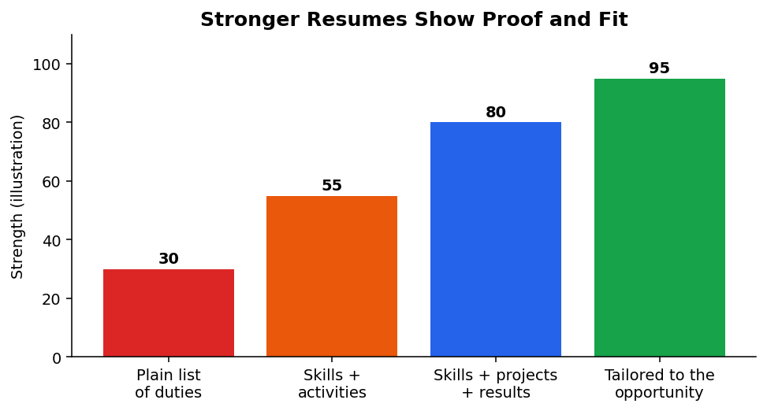
Figure 6.1: Resumes become stronger when they show skills, projects, results and fit

6.3 What Makes a Profile Strong?
Quality | What it looks like
Honest | Everything is true and can be explained
Clear | Short sentences, simple words, neat layout
Specific | Names, numbers and results instead of vague words
Relevant | Matches the purpose: a course, internship or competition
Consistent | Same facts and tone on every document and page
Up to date | Reviewed and improved every few months
Safe | No private or risky details shared publicly

6.4 Profile Audit: Where Am I Now?
Rate each part of your profile today. Be honest; this is only for you.
Part | Not started | Beginning | Good | Strong
Resume
Portfolio
Online profile
Skills list
Network
Personal brand

6.5 Your Profile Kit
Think of your profile as a kit that you carry. When an opportunity appears (a scholarship, an internship, a competition, a chance to meet a mentor), you can take out your kit and be ready within minutes.
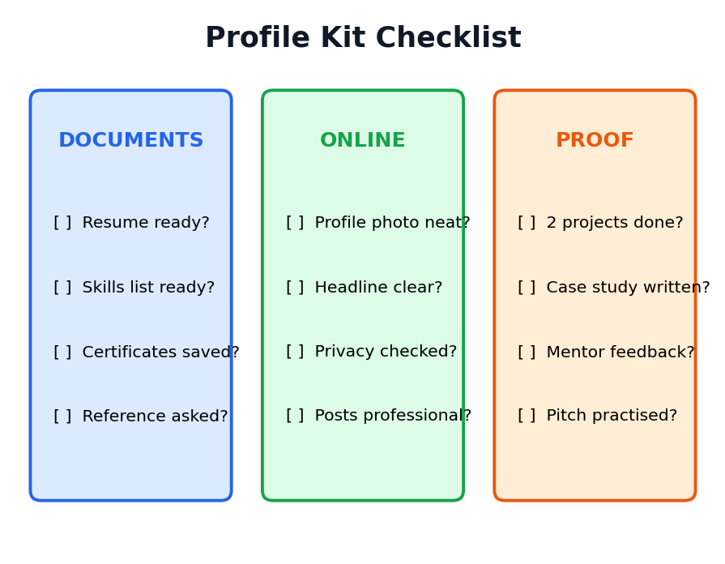
Figure 6.2: Profile Kit checklist (documents, online presence, proof)
ACTIVITY 6.1: START YOUR KIT
Create a folder on a computer (or a file at home) called My Launchpad File. Make three sub-folders: Documents, Projects and Certificates. Put in your school certificates, any competition awards and a list of your skills. Write today's date on a first-page sheet.

6.6 Chapter Summary
- A profile is a story with proof: claim plus proof gives credibility.
- The six parts: resume, portfolio, online profile, skills list, network and personal brand.
- A strong profile is honest, clear, specific, relevant, consistent, up to date and safe.
- Create a Profile Kit so that you are ready when opportunities come.
CHAPTER 7

Writing a Great Resume
A clear one-page document that opens doors
CHAPTER GOALS
- Understand what a resume is and why it matters.
- Learn the sections of a student resume.
- Use action words and numbers to show results.
- Avoid common resume mistakes.

7.1 What Is a Resume?
A resume (also called a CV, Curriculum Vitae) is a short document that summarises your education, skills, projects and activities. People who read many applications look at each resume for only a few seconds, so yours must be clear, neat and easy to scan.
TIP
For a student, one page is enough. Keep it simple, readable and honest.

7.2 A Student Resume Layout
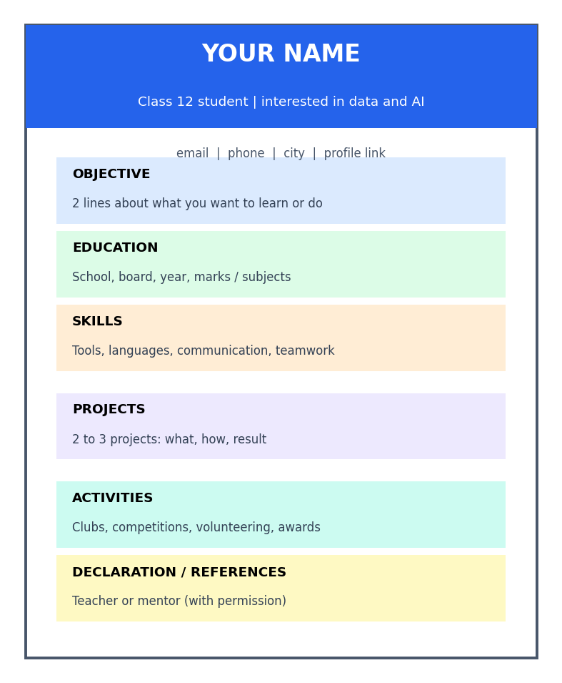
Figure 7.1: A simple one-page resume layout for a student

7.3 Section by Section

Heading: name and contact
Write your full name in a bigger size. Add a professional email address (for example, firstname.lastname at a standard email service), phone number and city. Do not use unprofessional email names such as 'coolboy123'.

Objective (or Summary)
Write two lines about who you are and what you want to learn or do. Make it specific.
Weak objective | Strong objective
Seeking a good opportunity to grow. | Class 12 science student interested in data and AI, seeking a beginner internship to learn practical data analysis.
I want to work in a big company. | Curious learner who enjoys solving problems with spreadsheets and basic Python; looking to join a school-level AI project team.

Education
List your school, board, class, year and main subjects. Add marks or grade if they are good and the reader may need them. Add any courses you have completed.

Skills
Group your skills so that they are easy to scan, for example: Digital: spreadsheets, presentations, basic Python. Human: teamwork, public speaking. Languages: Tamil, English. Only list skills you can honestly demonstrate.

Projects
This is the most powerful section for students without work experience. Write two or three projects with one line each on what you did, how and the result.

Activities and achievements
Include clubs, sports, competitions, volunteering, leadership roles, awards and certificates. Mention numbers where possible.

References
You may write 'References available on request', or include a teacher or mentor only with their permission.

7.4 Action Words and Numbers
Start each line with a strong action word and add numbers to show size or result.
Weak line | Strong line
Was in charge of the science club. | Led a 12-member science club and organised 3 experiments for 150 students.
Did a project on water. | Built a model of rainwater harvesting and presented it to 40 visitors at the school exhibition.
Good at computers. | Created a spreadsheet to track class attendance, saving the teacher about 20 minutes daily.
Helped juniors. | Tutored 5 juniors in maths for 2 months; their test scores improved.

Useful action words: led, organised, created, built, designed, analysed, presented, taught, improved, solved, collected, managed, tested, helped.

7.5 A Sample Student Resume (Text Version)
SAMPLE: KARTHIK R. (IMAGINARY)
Class 12 student | Interested in data and AI
karthik.r@example.com | City | Phone
OBJECTIVE: Curious Class 12 student who enjoys solving problems with data. Seeking a beginner learning opportunity in data analysis.
EDUCATION: XYZ Higher Secondary School, Class 12 (Maths, Physics, Chemistry, Computer Science), expected 2027. Completed an introductory online course in spreadsheets.
SKILLS: Spreadsheets, presentations, basic Python | Teamwork, public speaking | Tamil, English.
PROJECTS: (1) Class survey on study habits: collected 80 responses, made charts and shared 3 findings with the teacher. (2) School energy-saving poster: researched electricity use and designed a poster used in 6 classrooms.
ACTIVITIES: Member of the school debate team; volunteer in the school library; 2nd prize in the district science quiz.
REFERENCES: Available on request.

7.6 Ten Common Resume Mistakes
# | Mistake | Better approach
1 | Spelling and grammar errors | Read aloud; ask a teacher to check
2 | Too long or crowded | One page, white space, simple fonts
3 | Untrue or exaggerated claims | Write only what you can prove and explain
4 | Vague words like 'hard-working' | Show an example or a result
5 | Unprofessional email address | Use a simple name-based email
6 | Same resume for every opportunity | Adjust the objective and skills for each
7 | Too much personal information | Do not include ID numbers or full home address
8 | Fancy decoration and many colours | Use a clean, readable design
9 | Missing dates and details | Add months/years and short descriptions
10 | Copying AI text without checking | Check every line is true and in your own voice

CAREFUL
Never write false marks, fake certificates or invented experience. A false claim can be discovered and can damage your reputation and future chances.

ACTIVITY 7.1: WRITE YOUR FIRST RESUME
Using the layout in Figure 7.1 and the sample above, write your own one-page resume. Use action words and numbers. Ask a teacher and a friend to review it and give two suggestions. Improve it and save it as a PDF named with your name.

7.7 Chapter Summary
- A resume is a short, clear summary of your education, skills, projects and activities.
- Sections: heading, objective, education, skills, projects, activities, references.
- Use action words, numbers and results; keep it to one page.
- Be honest, check spelling and avoid risky personal details.
CHAPTER 8

Building Your Portfolio
Showing what you can do through real projects
CHAPTER GOALS
- Understand what a portfolio is and why it is powerful.
- Choose and plan small but meaningful projects.
- Write a clear case study for each project.
- Present and protect your work.

8.1 What Is a Portfolio?
A portfolio is a collection of your best work that shows your skills and your way of thinking. Artists, designers and writers have always used portfolios. Today, students who want to study or work in technology, business, science or any field can use portfolios to show their abilities before they have a job.

8.2 Why Portfolios Are Powerful
- They give proof that goes beyond marks.
- They show your thinking process, not only the final answer.
- They help you remember and reflect on what you have learned.
- They make you stand out among many applicants.
- They give you talking points during interviews.

8.3 Project Ideas for Class 12 Students
Interest area | Project idea | Skills shown
Data | Survey your class about a topic; clean the data; make charts and write three findings | Data collection, spreadsheets, communication
AI literacy | Test an AI tool on 20 school-level questions; record where it was right and wrong; write a short guide for juniors | Critical thinking, testing, writing
Environment | Measure waste or electricity use in school for a week; suggest and test one improvement | Observation, analysis, problem solving
Design | Design a poster or simple app screen for a school problem | Creativity, user focus
Business | Make a one-page business plan for a small student startup | Planning, costing, communication
Coding | Write a small program, such as a quiz game or a marks calculator | Logic, patience, testing
Social service | Organise a digital-literacy session for elders | Leadership, teaching, empathy

8.4 Plan a Project with the 3P Workflow
You can use the Prompt-Plan-Produce workflow from the earlier part of this course for every project.
Step | In your project
PROMPT | Ask good questions: what problem will I solve? Use AI for ideas, but choose yourself.
PLAN | Write the goal, steps, time, tools and how you will check success.
PRODUCE | Create, test, improve and document. Check facts and keep your own voice.

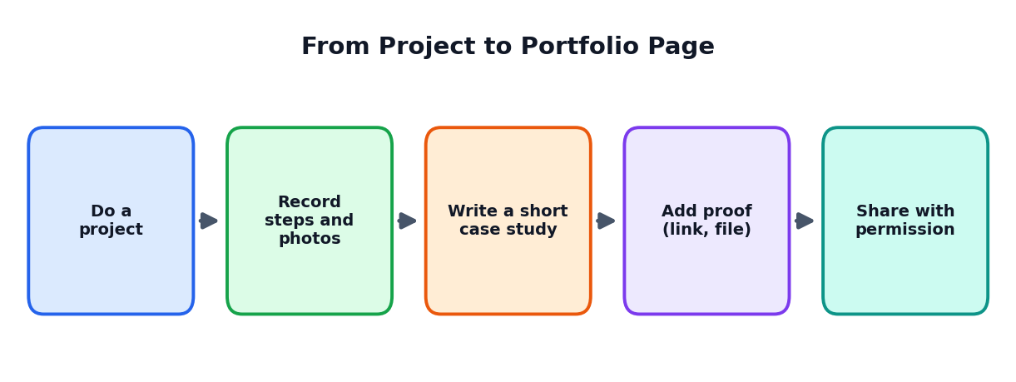
Figure 8.1: Turning a project into a portfolio page

8.5 Writing a Project Case Study
A case study is a short story about your project. Use this simple structure.
Part | Questions to answer | Length
Title | What is the project called? | One line
Problem | What problem or question did I work on? Why does it matter? | 2 to 3 lines
My role | What exactly did I do? Was it a team project? | 2 lines
Process | What steps did I follow? What tools did I use? | 4 to 6 lines
Result | What happened? Add numbers, photos or links | 3 lines
Learning | What did I learn? What would I do differently? | 2 to 3 lines

MINI CASE STUDY (IMAGINARY STUDENT)
Title: Study Habits Survey of Class 12. Problem: Many classmates felt tired during evening study. I wanted to find common reasons. My role: I designed the questions, collected 80 responses and made charts. Process: I planned a 10-question form, checked it with my teacher, collected answers on paper, entered them in a spreadsheet and cleaned mistakes. Result: Sixty percent said they slept after midnight. I shared three suggestions with the teacher, who held a short talk on sleep. Learning: I learned that clear questions give better data, and next time I will test the form with five friends first.

8.6 Documenting Your Work
- Take photos or screenshots as you work.
- Save drafts and the final version with clear names and dates.
- Write short notes: what worked, what failed.
- Ask teammates and teachers for a line of feedback.
- If AI helped, write how it helped. Honest notes build trust.

8.7 Presenting and Protecting Your Portfolio
Do | Do not
Choose your best 3 to 5 projects | Add everything you ever made
Show the process and the result | Show only a final picture without explanation
Get permission before using photos of people | Share classmates' faces or details without consent
Remove private data such as addresses and phone numbers | Upload survey responses with names
Give credit to teammates and sources | Claim group work as only yours

ACTIVITY 8.1: FIRST PORTFOLIO PROJECT
Choose one project idea from Section 8.3. Use the 3P workflow to plan it in a week. Then write a case study of about 200 words using the six-part structure. Ask a teacher for feedback and add the final version to your Launchpad File.

8.8 Chapter Summary
- A portfolio is a collection of your best work with proof of skills and thinking.
- Small, real projects are enough for a Class 12 portfolio.
- Use the 3P workflow to plan and complete projects.
- Write a case study: title, problem, role, process, result and learning.
- Respect privacy, give credit and be honest about AI help.
CHAPTER 9

Your Online Presence
Building a safe and professional presence on the internet
CHAPTER GOALS
- Understand your digital footprint.
- Learn to build a professional online profile.
- Use privacy settings and safe habits.
- Check your online image the way others see it.

9.1 Your Digital Footprint
Every time you post a photo, write a comment, join a website or search online, you leave small traces. All these traces together are your digital footprint. Colleges, employers and organisations may look at what is publicly visible about you. Much of your footprint stays for a long time, even if you delete a post, because others may have saved or shared it.
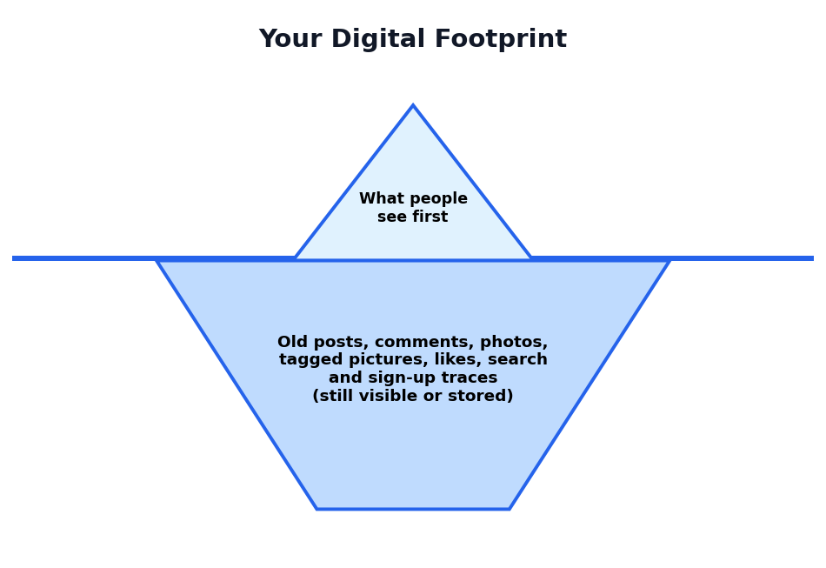
Figure 9.1: Like an iceberg, most of your digital footprint is below the surface
KEY IDEA
Think before you post. Ask: Would I be comfortable if my teacher, my parents and a future employer saw this?

9.2 Public and Private Spaces
Space | Example | Rule of thumb
Private | Chats with close friends, family photos | Share only what you are comfortable with; remember that messages can be forwarded
Semi-public | Class groups, clubs, small communities | Be respectful; assume many people may read
Public | Open profiles, public comments, videos | Treat it like a notice board visible to the whole world

9.3 Why Have a Professional Online Profile?
- It lets people find true and useful information about you.
- It shows your skills, projects and interests in one place.
- It helps you connect with mentors, learners and opportunities.
- It protects your name: if you do not create your story, others or random results may.
CAREFUL
Many professional networking sites have age rules. Check the terms of any website, and discuss with your parents or guardians before creating accounts. Never lie about your age to join a service.

9.4 Elements of a Good Profile Page
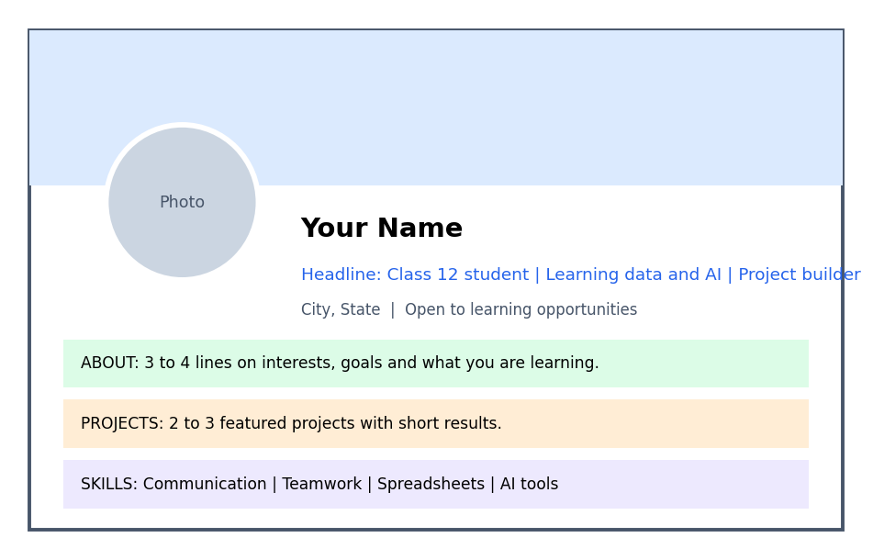
Figure 9.2: A sample layout of a professional profile page
Element | What to do
Photo | Use a clear, simple, neat photo; face visible; plain background. No filters or group photos.
Name | Use your real name as on documents.
Headline | One line about who you are and what you are learning. Example: Class 12 student | Learning data and AI | Builds small projects
About section | 3 to 4 lines on your interests, what you are learning and what you hope to do. Use simple, honest words.
Projects and activities | Add 2 to 3 projects with short results and links or pictures.
Skills | List real skills; you may ask teachers to confirm them.
Education | School name and years. Add courses completed.
Contact | Use a safe way to contact, such as the website's message option. Avoid sharing phone numbers publicly.

9.5 Writing a Good Headline and About Section
Weak | Better
Student | Class 12 student | Curious about data and AI | Built a class survey project
I like computers and many things. | I enjoy solving problems with data. This year I learned spreadsheets, made a survey project and began a beginner course in Python. I want to study computer science and help local businesses use technology.

9.6 Privacy and Safety Rules
- Use strong, different passwords and never share them.
- Turn on extra security (such as two-step verification) when available.
- Check privacy settings to control who can see your posts, photos and details.
- Do not share your home address, ID numbers, bank details, OTPs or exact daily routine.
- Accept connections carefully. Do not accept requests from people you do not know.
- Do not meet strangers from the internet alone. Tell a trusted adult.
- Report and block harassment, hate or suspicious messages; save evidence and tell a trusted adult.
- Keep your school and parents informed about your online activities.

9.7 Posting Like a Professional
Good posts | Avoid
A photo of your science project with a short note on what you learned | Angry rants about teachers or friends
Sharing a useful article with your own comment | Spreading forwards without checking facts
Thanking a mentor or helper | Bullying, rude jokes or hate comments
Congratulating a classmate on an achievement | Posting private pictures of others without permission

9.8 Search Yourself
Once every few months, search for your own name and check what appears. Look at your accounts as a stranger would. Remove or hide anything that does not represent you well, and correct wrong information.
ACTIVITY 9.1: DIGITAL FOOTPRINT AUDIT
1. List all websites and apps where you have an account.
2. For each, check the privacy settings and note changes you need.
3. Search your name and note what appears.
4. Write three rules for your own safe online behaviour.
5. If you are allowed to create a professional profile, draft the headline and about section on paper first and show it to a teacher.

9.9 Chapter Summary
- Your digital footprint is the trail of everything you do online.
- A professional profile has a clear photo, real name, headline, about section, projects and skills.
- Protect privacy: strong passwords, careful settings, no sharing of sensitive details.
- Post respectfully and truthfully; search yourself regularly.
CHAPTER 10

Personal Brand and Communication
How you speak, write and behave shapes the impression you make
CHAPTER GOALS
- Understand personal brand in a simple way.
- Prepare a 30-second self introduction.
- Write polite and clear emails and messages.
- Improve speaking and listening habits.

10.1 What Is a Personal Brand?
A personal brand is the picture that people have in their minds when they think of you. It comes from what you do, how you behave, how you speak and write, and what you stand for. You already have a personal brand, whether you plan it or not. This chapter helps you shape it in a positive and honest way.
Brand ingredient | Examples
Character | Honest, reliable, kind, respectful
Skills | Good at explaining, solving problems, designing
Style | Neat, calm, enthusiastic, organised
Reputation | What teachers and friends say about you

TIP: THREE-WORD BRAND
Choose three words that you want people to say about you, such as curious, dependable, helpful. Check whether your daily actions match those words.

10.2 The 30-Second Self Introduction
When you meet a teacher, mentor, interviewer or new friend, you may be asked, 'Tell me about yourself.' Prepare a short, friendly answer in four parts.
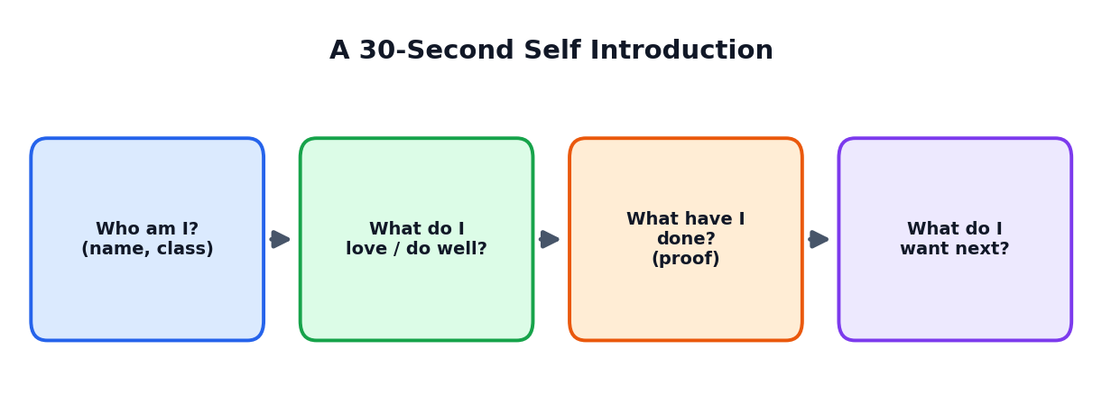
Figure 10.1: A four-part self introduction
SAMPLE INTRODUCTION
"Hello, I am Divya, a Class 12 student from Coimbatore. I enjoy biology and solving problems with data. Last year I led a team that built a rainwater harvesting model, and I am now learning spreadsheets and basic Python. I would like to study a course that connects health and technology, and I am here to learn from your experience."

ACTIVITY 10.1: YOUR PITCH
Write your own 30-second introduction (about 70 words). Practise it aloud in front of a mirror, then in front of a friend. Record yourself, listen and improve clarity, speed and confidence.

10.3 Writing Professional Messages
Writing emails and messages in a clear, polite and complete way is a valuable skill. Here is a good structure.
Part | What to write
Subject line | Short and specific, e.g. 'Request for advice on data careers'
Greeting | Dear Sir/Madam or Dear Mr./Ms. [Name]
Opening | Who you are, in one line
Main message | What you want, in two to four short sentences
Thanks | Show appreciation
Closing | Yours sincerely, your full name and class/school

SAMPLE EMAIL (IMAGINARY)
Subject: Request for 15 minutes of advice on data careers
Dear Ms. Lakshmi,
I am Karthik, a Class 12 student at XYZ Higher Secondary School. I am interested in a career in data analysis and I read about your work in the school alumni newsletter. Could I please ask you three short questions about your career path? I can talk on the phone or by message at a time that suits you.
Thank you for your time and consideration.
Yours sincerely,
Karthik R., Class 12, XYZ Higher Secondary School

10.4 Communication Etiquette Checklist
- Use polite words: please, thank you, sorry.
- Reply within a reasonable time.
- Check names, spelling and attachments before sending.
- Do not use all capital letters (it looks like shouting).
- Keep messages short; avoid unnecessary jokes with seniors.
- In group chats, think before you send; do not spam.

10.5 Speaking with Confidence
- Prepare: know your key points.
- Practise: speak aloud many times.
- Breathe: slow breathing calms nerves.
- Speak clearly: moderate speed, clear voice.
- Look at people: make eye contact.
- Use simple words: do not try to sound fancy.
- Pause: a short silence is fine.
- End strongly: finish with a clear message.

10.6 Listening: The Hidden Skill
Good communicators listen carefully. Listening means paying full attention, not interrupting, asking questions and showing respect with your face and body. People remember those who listen well.
Good listening | Poor listening
Look at the speaker | Check the phone while they speak
Nod and ask a follow-up question | Interrupt with your own story
Note key points | Think only of what you will say next
Say 'Thank you for explaining' | Walk away without a word

10.7 Appearance and Behaviour
For interviews, meetings and events, wear neat, comfortable and suitable clothing. Be on time, bring copies of your documents and keep your phone silent. Greet respectfully, sit properly and thank the people at the end. Small habits give a strong impression of seriousness.

10.8 Chapter Summary
- Your personal brand is the impression people form of you; shape it honestly.
- A four-part introduction covers who you are, what you love, what you have done and what you want next.
- Professional messages have a clear subject, greeting, purpose, thanks and closing.
- Speaking, listening, punctuality and neat appearance support your brand.
CHAPTER 11

Using AI to Build Your Profile
Smart, honest and safe ways to get help from AI tools
CHAPTER GOALS
- Learn what AI can and cannot do for your profile.
- Use AI for brainstorming, polishing and practice.
- Keep honesty, privacy and your own voice.
- Use sample prompts for resumes, projects and interviews.

11.1 AI as a Career Coach: Helpful but Not the Boss
Generative AI tools can help you improve your profile. They can suggest better wording, give feedback on your resume, ask mock interview questions and help you plan your learning. But AI does not know your life, and it can make mistakes or invent facts. The profile must always be true and must always sound like you.
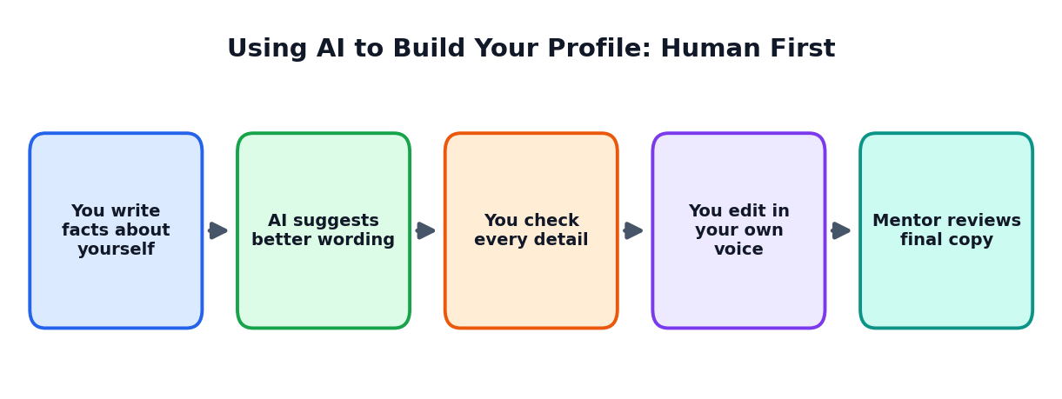
Figure 11.1: Human first, AI second, human final

11.2 What AI Can Do for Your Profile
Task | How AI can help | What you must do
Self-reflection | Ask questions to help you think | Answer honestly; decide yourself
Career research | Explain roles and skills in simple language | Verify with official or trusted sources
Resume wording | Suggest clearer lines and action words | Keep only what is true; use your own voice
Grammar and clarity | Find mistakes and awkward sentences | Accept changes that keep your meaning
Mock interviews | Ask questions and give feedback | Practise aloud; treat feedback as ideas
Learning plans | Create a first schedule | Adjust to real life and check courses yourself
Project ideas | Suggest options | Choose, plan and complete projects yourself

11.3 What AI Must NOT Do for Your Profile
NEVER DO THESE
- Do not let AI invent experiences, marks, awards or skills you do not have.
- Do not copy a full AI-written resume or essay and submit it as your own.
- Do not paste private details such as ID numbers, full address, bank data or passwords.
- Do not use AI to create fake certificates, fake recommendations or fake profiles.
- Do not trust any fact from AI (about courses, fees, dates, rules) without checking an official source.

11.4 Sample Prompts
PROMPT 1: IMPROVE RESUME LINES (WITHOUT INVENTING FACTS)
"Act as a school career counsellor. Below are three lines from my resume. Improve the wording using strong action words and keep the facts exactly the same. Do not add any new information or numbers. Lines: [paste your lines]"

PROMPT 2: MOCK INTERVIEW
"Act as an interviewer for a beginner internship in data analysis. Ask me one question at a time. Wait for my answer. After each answer, give feedback in two lines: one strength and one improvement. Start with 'Tell me about yourself.'"

PROMPT 3: SKILLS GAP
"I am a Class 12 student interested in [career]. Here is my current skills list: [list]. Suggest 8 skills I should build in the next 6 months. For each, give one free or low-cost way to practise it. Use a table."

PROMPT 4: PROJECT IDEAS
"Suggest 8 small project ideas for a Class 12 student interested in [field] that can be completed in two weeks using free tools. For each, give the goal, the steps and what I would show in my portfolio."

PROMPT 5: EMAIL CHECK
"Check this email to a mentor for tone, clarity and spelling. Suggest improvements but keep it short and polite. Do not make it sound too formal or unnatural. Email: [paste email]"

11.5 The 5-Step Check Before You Use Any AI Text
- Truth: Is every fact correct? Can I prove it?
- Voice: Does it sound like me, in simple natural words?
- Privacy: Did I avoid sharing sensitive details?
- Fit: Does it match the purpose and the reader?
- Honesty: Am I comfortable explaining every line if someone asks?

11.6 Being Open About AI Help
Many schools and organisations allow AI support for brainstorming or checking language, but have rules against submitting AI-written work as your own. Learn your school's rules. If AI helped you, a short note such as 'I used an AI tool to check grammar and suggest wording; all facts and final text are mine' shows honesty and maturity.
TIP
If you can explain every line of your resume without looking at it, then it truly belongs to you.

ACTIVITY 11.1: AI-ASSISTED, HUMAN-CHECKED
Take two lines from your resume. Ask an AI tool to improve them using Prompt 1. Compare the two versions. Write which words you accepted, which you rejected and why. Add a line about what you learned about using AI honestly.

11.7 Chapter Summary
- AI can help with reflection, research, wording, mock interviews and planning.
- It must never invent facts or replace your own effort and voice.
- Protect private data; verify important information from official sources.
- Use the five checks: truth, voice, privacy, fit and honesty.
- Be open about how you used AI when rules or situations require it.
CHAPTER 12

Networking and Mentors
Growing with the help of people
CHAPTER GOALS
- Understand networking as building honest relationships.
- Learn how to find and approach mentors.
- Write polite messages and ask good questions.
- Give as well as receive.

12.1 What Is Networking?
Networking means building and keeping friendly, helpful relationships with people. It is not about using people. It is about learning from each other, sharing ideas and supporting one another. Many opportunities, such as advice, internships, projects and recommendations, come through people who know and trust you.
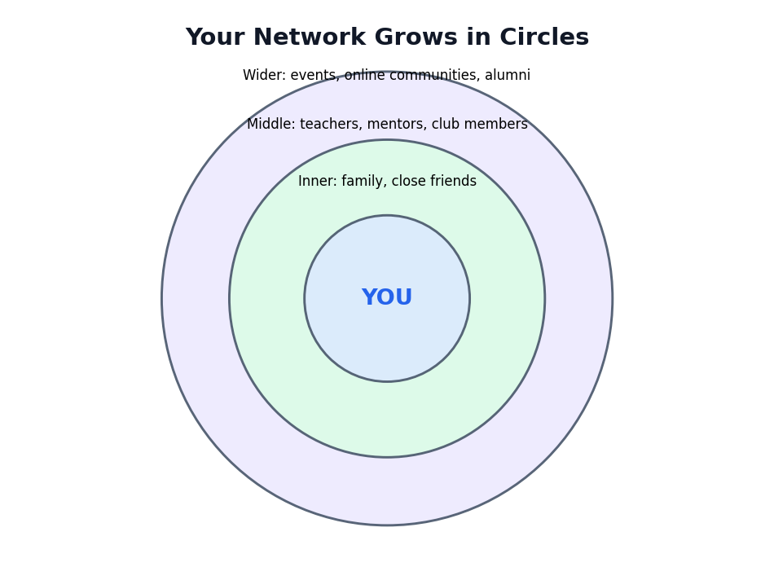
Figure 12.1: Your network grows in circles

12.2 Who Is in Your Network Already?
Circle | People | How they can help
Inner | Family and close friends | Support, honest feedback, encouragement
Middle | Teachers, mentors, club members, neighbours, relatives with different jobs | Advice, guidance, introductions, recommendation letters
Wider | Alumni, event participants, online learning communities | New ideas, information about courses and careers

TIP
Start with the people you already know. Your teachers and relatives may know people whose work you would like to learn about.

12.3 What Is a Mentor?
A mentor is an experienced person who gives guidance, shares experience and encourages your growth. A mentor does not do your work for you; they help you think better, avoid mistakes and see new possibilities.

Qualities to look for in a mentor
- Has experience in an area you wish to learn about.
- Is respectful, honest and willing to listen.
- Is available for short, regular conversations.
- Cares about your growth, not only their own benefit.

Where can you find mentors?
- Teachers, school counsellors and school alumni.
- Professionals in your family circle or neighbourhood.
- Speakers at school events or workshops.
- Community clubs and learning groups (with parents' awareness).

12.4 Informational Conversations
An informational conversation is a short talk (10 to 20 minutes) to learn about someone's work or career path. You are not asking for a job; you are asking for advice and stories.

Good questions to ask
- How did you choose your career?
- What does a typical day look like?
- Which skills are most important in your work?
- What do you wish you had known at my age?
- How is AI changing your field?
- Is there anyone else you suggest I speak to?

Before, during and after
When | What to do
Before | Read about the person's work; prepare 5 questions; confirm time and place; take a notebook
During | Be on time; introduce yourself; listen; take notes; keep to the time
After | Send a thank-you message within a day; mention one useful thing you learned

12.5 Sample Message Templates
REQUEST TO A TEACHER OR ALUMNUS
Dear Sir/Madam, I am [Name], a Class 12 student of [School]. I am interested in [field] and read about your work in [place]. Could I please have 15 minutes of your time to ask a few questions about your career path? I am happy to adjust to your convenience. Thank you for considering my request. Yours sincerely, [Name]

THANK-YOU MESSAGE
Dear Sir/Madam, Thank you for speaking with me today. I especially learned that [one point]. I will try [one action] after your advice. I really appreciate your time and guidance. Regards, [Name]

12.6 Giving Back
Networking works best when it goes both ways. You can help by sharing useful articles, volunteering to help with school events, supporting juniors, thanking mentors and keeping your promises. Even as a student, you have something to give: your energy, new ideas, and your time.

12.7 Safe Networking
- Tell your parents or guardian whom you are meeting or messaging.
- Meet in public or school settings, or have a trusted adult present.
- Be careful with people who ask for money, personal photos, or secrets.
- Use official school or organisation channels where possible.
- If anything feels uncomfortable, stop and tell a trusted adult.
ACTIVITY 12.1: NETWORK MAP
Draw three circles like Figure 12.1. Write names of people in each circle. Choose one person you would like to learn from. Write five questions. With permission, hold a 15-minute conversation and send a thank-you message. Write what you learned.

12.8 Chapter Summary
- Networking means building honest, helpful relationships.
- Mentors guide your thinking; they do not do your work.
- Informational conversations are short talks to learn about careers.
- Be polite, prepared, thankful, and safe. Give back where you can.
CHAPTER 13

Applications and Interviews
How to apply and how to speak confidently when asked questions
CHAPTER GOALS
- Understand the journey of an application.
- Fill forms and cover notes correctly.
- Use the STAR method to answer questions.
- Prepare for interviews and group discussions.

13.1 The Journey of an Application
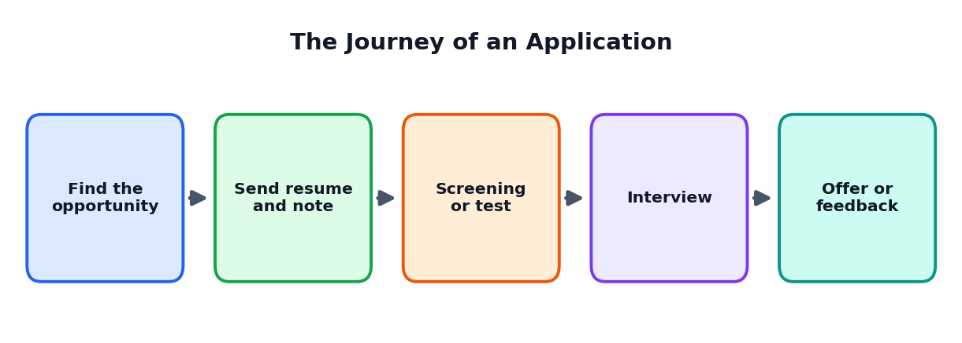
Figure 13.1: The usual steps of an application

13.2 Reading the Opportunity Carefully
Before applying for a course, internship, scholarship or competition, read the details carefully. Note the eligibility, last date, documents, selection process and contact details. Many applications fail only because of simple mistakes like missing dates or documents.
Check | Question
Eligibility | Do I meet the requirements?
Dates | What is the last date? Is there a test or interview date?
Documents | Which certificates, photos and forms do I need?
Cost | Is there a fee? Is the source official and genuine?
Contact | Whom can I ask if I have doubts?

13.3 Application Forms and Cover Notes
- Fill forms carefully and completely; check spelling and numbers.
- Write your name exactly as it appears in your documents.
- Keep copies of what you submit.
- Write a short cover note: who you are, why you are applying, what you can offer, and thanks.
SAMPLE COVER NOTE (IMAGINARY)
Dear Sir/Madam, I am Priya, a Class 12 student. I wish to apply for your two-week learning internship in data analysis. I have completed a class survey project and a beginner spreadsheet course, and I enjoy solving problems with data. I would be grateful for the chance to learn from your team and to contribute with sincerity and hard work. My resume is attached. Thank you for your consideration. Yours sincerely, Priya

13.4 Types of Interviews and Tests
Type | What happens | How to prepare
Personal interview | Panel or one person asks you questions | Know your resume; practise answers; be honest
Group discussion | A group talks about a topic while observers watch | Listen, speak clearly, respect others, summarise
Written test | Questions on aptitude, subjects or reasoning | Practise past questions and time management
Practical task | You show a skill, such as making a slide or solving a data task | Practise with small tasks
Online interview | Video call from home or school | Test internet, camera and sound; sit in a quiet, well-lit place

13.5 The STAR Method
Interviewers often ask about your past experience: 'Tell me about a time when you worked in a team.' A clear way to answer is the STAR method.
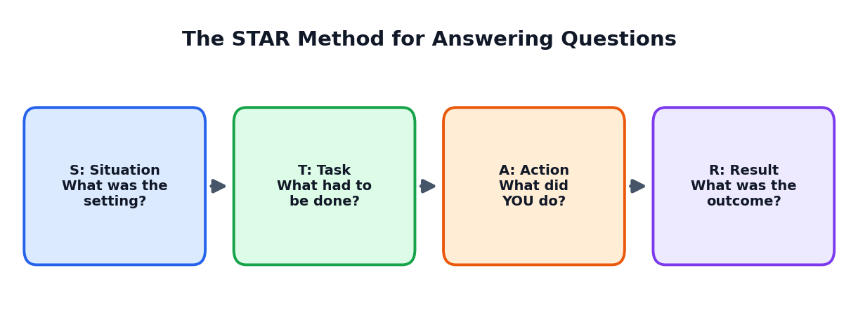
Figure 13.2: Situation, Task, Action, Result
STAR ANSWER (IMAGINARY)
Question: Tell me about a time you solved a problem.
Situation: In our school science exhibition, our water model leaked just one day before the event.
Task: I had to fix it quickly, as our team was presenting the next day.
Action: I checked each joint, found a crack in a pipe, and replaced it with a thicker pipe and sealant after asking my teacher. I also made a backup plan with pictures in case the model failed.
Result: The model worked well, and we won second prize. I learned to test early and keep a backup plan.

13.6 Common Interview Questions
Question | How to think about it
Tell me about yourself. | Use your 30-second introduction (Chapter 10)
Why do you want this course or opportunity? | Link your interests, projects and goals to it
What are your strengths? | Name two with proof (a project or example)
What is your weakness? | Name a real one and say what you are doing to improve it
Tell me about a challenge you faced. | Use the STAR method
How do you use AI in your studies? | Explain honestly: how it helps, how you check facts, and your own effort
Where do you see yourself in five years? | Describe learning goals, not unrealistic promises
Do you have any questions for us? | Ask about learning opportunities, projects and expectations

13.7 Group Discussion Tips
- Listen first; do not interrupt.
- Make clear points with an example.
- Respect other opinions; say 'I agree with... and would add...'.
- Bring the group back to the topic if it drifts.
- Do not shout or dominate; quality matters more than quantity.
- If possible, give a short summary at the end.

13.8 Interview Day Checklist
Before | During | After
Research the organisation  Prepare documents and copies  Plan route and time  Sleep well | Be on time  Greet politely  Listen to the full question  Answer honestly and briefly | Send a thank-you note  Write what went well  Note what to improve  Keep applying and learning

13.9 Handling Rejection
Not every application will succeed. Rejection is a normal part of every career. Ask for feedback if possible, learn something from the experience, and try again. Many successful people were rejected many times before they succeeded.
ACTIVITY 13.1: MOCK INTERVIEW DAY
Practise with a partner. One plays the interviewer using the question list; the other answers using the STAR method and the 30-second introduction. Swap roles. Give each other two strengths and two improvements. You may also use an AI tool for a practice round, but always practise aloud with a real person too.

13.10 Chapter Summary
- Read each opportunity carefully; check eligibility, dates, documents and cost.
- Fill forms and cover notes carefully and politely.
- Use the STAR method to answer experience-based questions.
- Prepare for different interview types and handle rejection with a learning attitude.
CHAPTER 14

Your Learning Plan and Goals
Turning dreams into daily actions
CHAPTER GOALS
- Set clear SMART goals.
- Use the goal ladder to connect dreams and daily steps.
- Make a 90-day launch plan.
- Build habits that keep you going.

14.1 Why Goals Matter
Without a goal, it is easy to drift. With a goal, you know what to do next. But big goals can feel scary. The secret is to break them into smaller goals that you can finish step by step.

14.2 The Goal Ladder
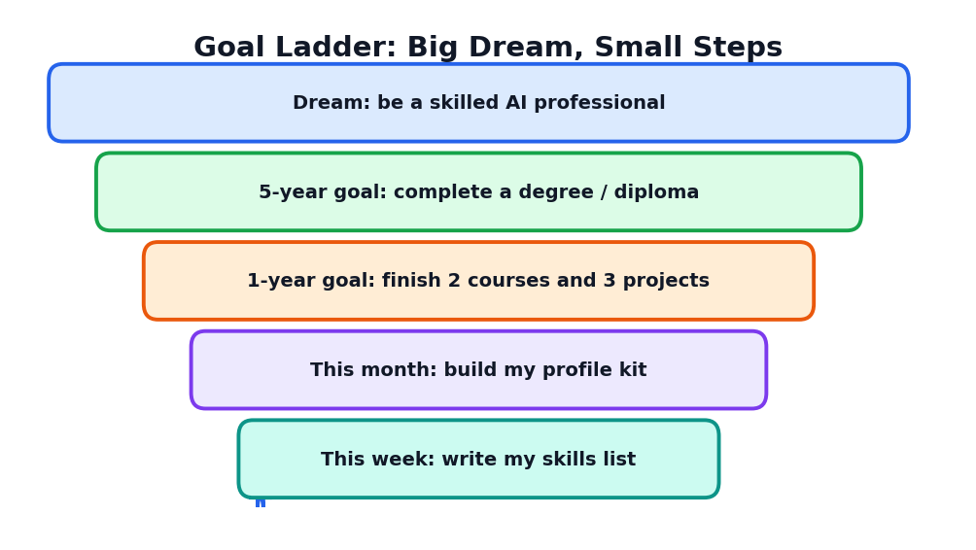
Figure 14.1: A goal ladder connects a long dream to this week's action
Start at the top with your dream, then go down step by step to something you can do this week. If a step feels too big, break it into smaller parts.

14.3 SMART Goals Again
Letter | Meaning | Weak goal | SMART goal
S | Specific | Learn AI | Finish a beginner course on data basics
M | Measurable | Practise more | Complete 3 exercises per week
A | Achievable | Master coding in one week | Learn basic Python in 8 weeks
R | Relevant | Learn many random things | Choose skills that connect to my chosen career
T | Time-bound | Someday | Finish by 31 December

14.4 Your 90-Day Launch Plan
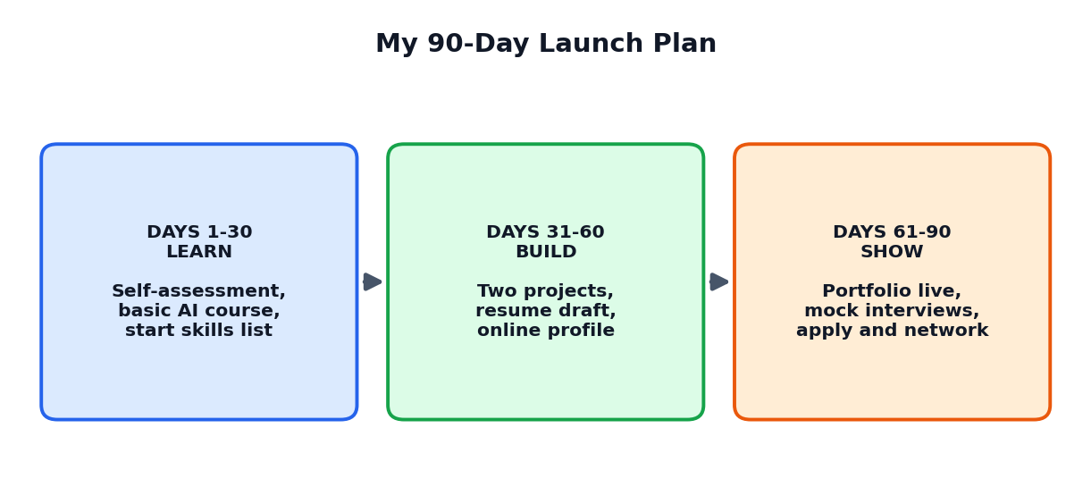
Figure 14.2: A 90-day plan with three phases: learn, build, show
Phase | Goals | Actions
Days 1 to 30: LEARN | Know yourself; learn basic AI and digital skills | Self-assessment; skills inventory; two career research sheets; start a beginner course
Days 31 to 60: BUILD | Create proof of skills | Complete two projects; write case studies; draft resume and profile
Days 61 to 90: SHOW | Present and connect | Finalise portfolio; mock interviews; talk to two mentors; apply for one opportunity

14.5 Weekly Planning
A weekly plan turns your goals into actions. Every Sunday, spend 15 minutes planning the week.
Day | Learning task | Time
Monday | Course lesson (20 to 30 minutes) | 30 min
Tuesday | Practice exercise | 30 min
Wednesday | Project work | 45 min
Thursday | Course lesson and notes | 30 min
Friday | Project work | 45 min
Saturday | Reflect and update profile; talk to a mentor | 45 min
Sunday | Plan next week; rest | 15 min

TIP
Small daily practice beats a big effort once in a while. A short study every day is easy to keep and gives steady progress.

14.6 Building Good Habits
- Start tiny: make the habit so small that it is easy (10 minutes).
- Link it to an existing habit: for example, practise right after dinner.
- Track it: tick a calendar each day you practise.
- Reward yourself: celebrate small wins.
- Do not break the chain twice: if you miss a day, return the next day.

14.7 Handling Obstacles
Obstacle | Possible solution
No time | Find 20 minutes: reduce phone time; use travel time for audio learning
No internet or computer at home | Use school or library facilities; download materials in advance; ask teachers
Feeling lost | Talk to a teacher or mentor; reduce the goal size
Fear of failing | Remember: mistakes are part of learning; start small
Family pressure or different expectations | Share your plan with facts; ask a counsellor to help in discussions
Loss of motivation | Revisit your sweet spot; find a study partner

14.8 Reflect and Review
At the end of every month, review: What did I learn? What did I finish? What was difficult? What will I change? Keep your reflection short and honest. Reflection turns experience into wisdom.
ACTIVITY 14.1: WRITE YOUR 90-DAY PLAN
Fill a page with three columns: Learn (days 1 to 30), Build (31 to 60), Show (61 to 90). Write three SMART goals for each phase and one weekly routine. Share your plan with a teacher or parent, and fix a date for the first review.

14.9 Chapter Summary
- Goals give direction; the goal ladder links dream to weekly actions.
- SMART goals are specific, measurable, achievable, relevant and time-bound.
- A 90-day plan with learn, build and show phases makes the journey practical.
- Good habits, tracking and reflection keep you moving forward.
CHAPTER 15

Gaining Experience Early
Learn by doing: internships, volunteering, competitions, freelance and your own projects
CHAPTER GOALS
- Know the different ways to gain experience as a student.
- Learn how to find safe, genuine opportunities.
- Make the most of each experience.
- Record experiences in your profile.

15.1 Why Experience Matters
Experience shows that you can apply what you learn. It teaches you things that textbooks cannot: teamwork, responsibility, handling pressure and understanding real people. Even short experiences can make a big difference to your confidence and your profile.

15.2 Six Ways to Gain Experience
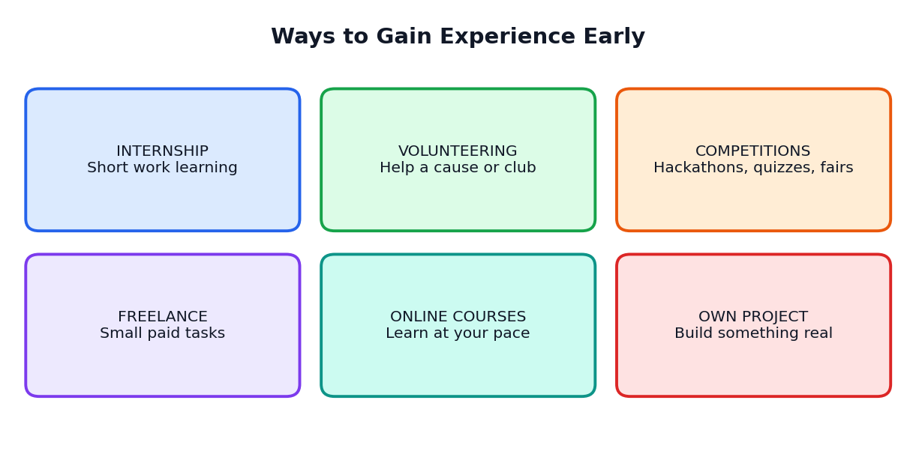
Figure 15.1: Six ways to gain experience early
Way | What it is | Example for a Class 12 student
Internship | A short period of learning by working with an organisation | A two-week observation internship at a local clinic, shop, school office or small company (with permission and safety)
Volunteering | Giving your time without pay to help a cause | Teaching juniors, helping in a library, organising a cleanliness drive
Competitions and fairs | Contests that test skills | Science fair, quiz, debate, poster contest, student hackathon
Freelance or small paid work | Small tasks done for payment | Making posters, helping with data entry, tutoring (with parents' permission and within the law)
Online courses | Structured learning at your own pace | A beginner course on data, design or digital marketing
Own project | Starting something yourself | A study-tips channel for juniors, a school app idea, a community survey

15.3 How to Find Genuine Opportunities
- Ask your school, teachers and counsellor first.
- Check notice boards of colleges, libraries and community centres.
- Ask relatives and neighbours who run businesses.
- Follow official pages of trusted organisations.
- Prefer opportunities recommended by someone you trust.

15.4 Spot the Scam
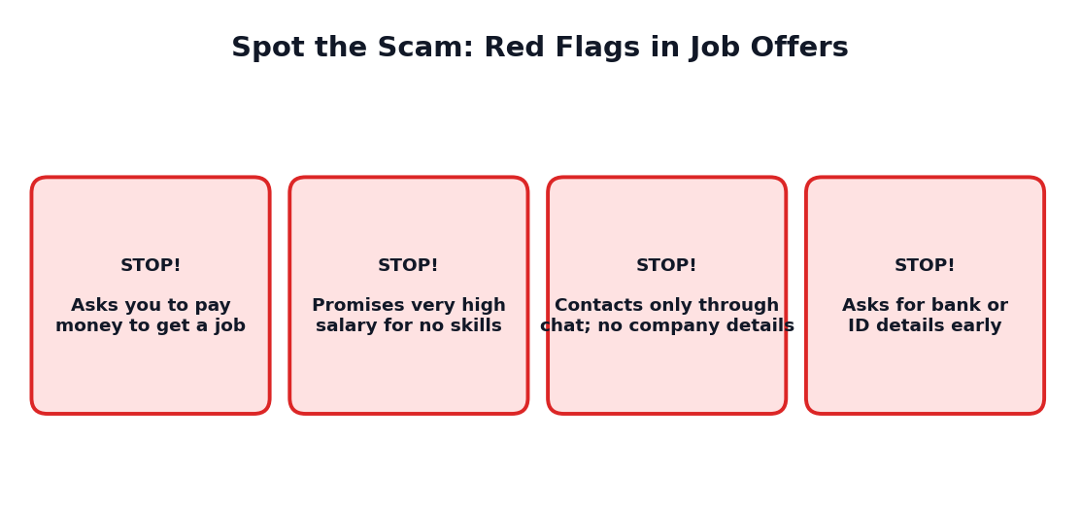
Figure 15.2: Red flags in fake job or course offers
CAREFUL
A genuine opportunity does not ask you to pay money just to get selected. If an offer looks too good to be true, it probably is. Never share OTPs, bank details, ID numbers or personal photos. Show any suspicious message to a parent, teacher or counsellor.

15.5 Making the Most of an Experience
Stage | What to do
Before | Set two learning goals. Ask what to wear and bring. Learn basic facts about the place.
During | Be on time, polite and curious. Ask questions. Take notes. Offer help.
After | Thank the people. Ask for feedback or a short recommendation note. Write a reflection and add to your profile.

15.6 Recording Your Experience
Keep a simple experience log to remember everything. Later it helps in writing your resume, portfolio and interview answers.
Date | Activity | My role | What I did | What I learned | Proof
Jan | School science fair | Team leader | Built a model; presented | Teamwork and testing | Photo, certificate

15.7 Student Entrepreneurship
Some students like to start small ventures, such as selling handmade products, offering tutoring or creating helpful digital tools. This teaches planning, money handling and customer care. Start small, keep your studies a priority, involve your parents, follow the rules and be honest with customers.
ACTIVITY 15.1: EXPERIENCE PLAN
Choose two ways from Figure 15.1 that you can try in the next three months. For each, write: What, Where, When, Who will help and What I want to learn. Take the plan to your teacher for suggestions.

15.8 Chapter Summary
- Experience builds skills, confidence and proof.
- Ways include internships, volunteering, competitions, freelance, online courses and own projects.
- Beware of scams; never pay for selection or share sensitive data.
- Keep an experience log and reflect after each activity.
CHAPTER 16

Professional Ethics and Online Safety
The values that make your profile trustworthy
CHAPTER GOALS
- Understand professional ethics in simple terms.
- Practise honesty, respect, responsibility, privacy and learning.
- Use AI and social media responsibly.
- Handle mistakes with integrity.

16.1 What Are Professional Ethics?
Ethics are the principles of right and wrong that guide our behaviour. Professional ethics are those principles in work and learning life. A person with strong ethics is trusted, and trust is the most valuable part of any career.
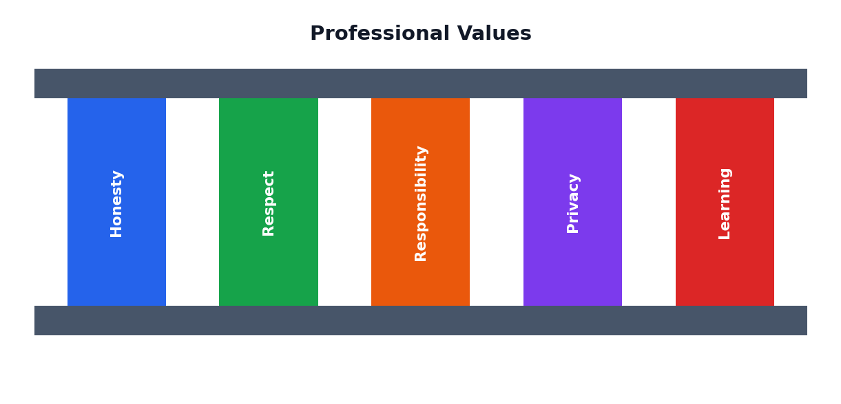
Figure 16.1: Five professional values

16.2 The Five Values
Value | Meaning | Example
Honesty | Telling the truth in words and actions | Writing only true facts in your resume; telling your teacher when AI helped
Respect | Treating everyone with dignity | Listening to others, avoiding insults, respecting different views
Responsibility | Doing your duty and owning your mistakes | Meeting deadlines; saying 'I made a mistake, and I will fix it.'
Privacy | Protecting information of yourself and others | Not sharing others' photos or data without permission
Learning | Staying humble and curious | Accepting feedback; learning new tools

16.3 Academic Honesty and AI
Using AI in learning is useful, but it can become cheating if used in the wrong way. The simple rule is: AI may help you learn, but it should not do the learning for you.
Honest use | Dishonest use
Asking AI to explain a hard concept in simple words | Submitting an AI-written assignment as your own
Asking for feedback on your own draft | Copying answers in an exam
Brainstorming ideas, then choosing yourself | Inventing data or sources
Checking grammar of your own writing | Asking AI to impersonate another student

16.4 Respecting Others' Work
- Give credit for ideas, pictures and quotes that are not yours.
- Do not copy large parts of text or designs.
- Ask permission to use someone's photo or work.
- Use only the content that is allowed to be used, and follow the rules.

16.5 Online Behaviour and Cyber Safety
Situation | What to do
Someone sends a rude or hateful message | Do not reply angrily. Save evidence. Block and report. Tell a trusted adult.
A stranger asks for personal photos | Refuse. Tell a trusted adult immediately.
You see a shocking post that may be fake | Pause. Check with reliable sources. Do not forward until verified.
Someone shares your private photo without permission | Ask them to delete it. Tell a trusted adult. Use reporting tools.
You make a mistake online | Remove the post, apologise if needed and learn from it.

16.6 Deepfakes and Fake Information
AI can create very realistic fake pictures, voices and videos. These can be used to cheat, hurt reputations or spread lies. Never create or share fake content to harm anyone. If you find fake content about yourself or someone you know, tell a trusted adult and report it on the platform or to the proper authority.

16.7 Owning Mistakes
Everyone makes mistakes. Ethical people do three things: they admit the mistake, fix what they can and learn to avoid it again. Hiding mistakes usually makes things worse. A person who is honest about errors earns respect.

16.8 Fairness and Inclusion
A good professional treats everyone fairly, regardless of gender, religion, caste, language, disability or economic background. When using AI tools, watch for biased outputs and edit them out. Include different voices in your teamwork, and speak up kindly when something is unfair.

16.9 Wellbeing: Take Care of Yourself
A strong career is built by a healthy person. Sleep well, eat properly, move your body, spend time with family and friends, and take breaks. If you feel very stressed, anxious or sad, talk to a trusted adult, school counsellor or doctor. Asking for help is a sign of strength, not weakness. A chatbot cannot replace caring humans.
ACTIVITY 16.1: MY CODE OF CONDUCT
Write your personal code of conduct with at least six rules, covering honesty, respect, privacy, AI use, online behaviour and wellbeing. Sign and date it and keep it in your Launchpad File.

16.10 Chapter Summary
- Ethics are principles of right and wrong; they build trust in your career.
- Five values: honesty, respect, responsibility, privacy and learning.
- Use AI to learn, not to cheat; give credit to others.
- Practise online safety; avoid fake content; own your mistakes.
- Take care of your wellbeing and ask for help when needed.
CHAPTER 17

Case Studies and Final Project
Five students' stories and your own Profile Kit
CHAPTER GOALS
- Learn from five imaginary students with different paths.
- Apply the ideas of this book to realistic situations.
- Create your own complete Profile Kit.

The students in these cases are imaginary. Their stories are written to help you think about choices, challenges and solutions. Each case follows the same journey.
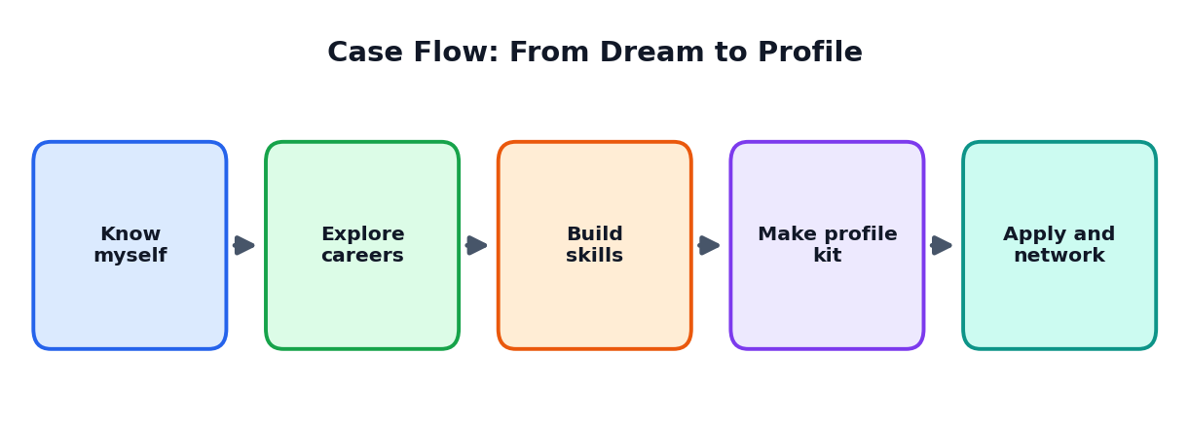
Figure 17.1: The journey from self-knowledge to application

Case Study 1: Meena, Interested in Both Biology and Technology
SITUATION
Meena likes biology and is also curious about computers. Her friends say that she must choose either medicine or software. She feels confused.

WHAT SHE DID
- Made her sweet-spot circles and found that 'helping people' and 'data' appeared in many places.
- Researched careers that mix health and technology, such as health data analysis and bio-related fields.
- Talked to a nurse and a data analyst and wrote down their advice.
- Started a beginner spreadsheet course and made a health-habits survey in her class.
- Wrote a resume with this project and an objective about health and data.

LEARNING
Interests do not have to fit into one box. Exploring, talking to people and doing a small project helped Meena move from confusion to direction.

Case Study 2: Karthik, Worried About Marks
SITUATION
Karthik's marks are average. He feels that colleges will not value him. He enjoys drawing and fixing electronic gadgets.

WHAT HE DID
- Listed his strengths with his teacher: practical skills, patience, creativity.
- Compared pathways such as diplomas and skill courses, degrees and apprenticeships using a scoring table.
- Built a project: a simple low-cost water-level alarm for a home tank, with a case study and photos.
- Added the project and a teacher's comment to his portfolio.
- Prepared a Plan B and Plan C and discussed them with his parents and counsellor.

LEARNING
Marks are important, but projects, skills and a clear story also matter. A realistic plan with backups reduced Karthik's worry.

Case Study 3: Divya, Living in a Village With Limited Internet
SITUATION
Divya lives in a small village. Internet is slow, and she has no computer at home. She wants to build digital skills.

WHAT SHE DID
- Used the school computer lab twice a week and the public library on Saturdays.
- Downloaded course materials when the connection was good, and studied them offline at home.
- Made a project with pen and paper first (a survey about water use in her village) and entered the data in a spreadsheet at school.
- Asked her teacher to be her mentor and review her work.
- Presented the findings to the village meeting, with her teacher's help.

LEARNING
Limited resources can be overcome with planning, creativity and support. A real local project impressed everyone who saw it.

Case Study 4: Arun, Using AI the Wrong Way, Then the Right Way
SITUATION
Arun asked an AI tool to write his whole resume. It added awards that he had never won and a project he had not done. A teacher noticed and talked to him.

WHAT HE DID
- He admitted the mistake and removed false details.
- He wrote his real facts first and used AI only to improve wording, keeping the facts the same.
- He checked every line and could explain it.
- He added a note in his portfolio on how he used AI.
- He later helped juniors by giving a talk on honest AI use.

LEARNING
Mistakes can be repaired through honesty. Using AI as a helper, not as a replacement for truth, builds trust.

Case Study 5: Priya, Preparing for an Interview
SITUATION
Priya applied for a student leadership programme and was called for an interview. She felt very nervous.

WHAT SHE DID
- Wrote and practised her 30-second introduction.
- Prepared three STAR stories from her school activities.
- Practised with a teacher and then with a friend, and did one practice round with an AI interviewer.
- Prepared two questions to ask the panel.
- Arrived early with documents, spoke calmly and sent a thank-you note after the interview.

LEARNING
Preparation reduces fear. Real people gave her the best feedback, and AI practice added extra repetition.

Comparing the Cases
Student | Main challenge | Key action | Main lesson
Meena | Confusion about direction | Sweet spot, research, small project | Explore and try
Karthik | Worry about marks | Strengths, scoring table, hands-on project | Skills and projects matter
Divya | Limited resources | Offline learning, shared facilities, mentor | Planning beats limits
Arun | Misusing AI | Admitted, fixed, used AI honestly | Honesty rebuilds trust
Priya | Interview nerves | Practice, STAR stories, thank-you note | Preparation builds confidence

Your Final Project: My Professional Profile Kit
Now you will create your own complete Profile Kit. You may work on it during the whole course and present it at the end. The kit must be honest, neat and based on your own work.

Contents of the Profile Kit
Part | What to include | Chapter
1. About Me | Sweet-spot circles, interests, strengths, values and top skills | 2
2. Career Research | Two career research sheets and a skills gap table | 3, 4
3. Pathway Plan | Scoring table for two or three pathways, with a Plan B | 5
4. Resume | One-page resume (PDF) | 7
5. Portfolio | At least two projects with case studies | 8
6. Online Presence Plan | Digital footprint audit; draft headline and about section | 9
7. Communication | 30-second introduction and a sample email | 10
8. AI Use Note | Short note on how you used AI honestly, with your 5-step checks | 11
9. Network Map | Network circles; notes from one informational conversation | 12
10. Interview Prep | Three STAR stories and answers to five common questions | 13
11. 90-Day Plan | Learn, build and show plan; weekly routine | 14
12. Experience Plan and Code of Conduct | Two experience goals; personal code | 15, 16

Presentation
Prepare a 5-minute presentation: your introduction, your sweet spot, one project, your plan and one thing you learned. Answer questions from your teacher and classmates.

Assessment rubric
Criteria | 4 (Excellent) | 3 (Good) | 2 (Fair) | 1 (Needs work)
Self-knowledge | Deep, honest, with examples | Clear and honest | Basic | Unclear
Career research | Detailed, verified sources | Good detail | Some detail | Little research
Resume and portfolio | Neat, specific, proof-based | Good and clear | Basic | Incomplete
Communication | Confident, clear, well prepared | Clear | Unsure | Unclear
Plan quality | SMART, realistic, with backups | Mostly SMART | General | Missing
Honesty and ethics | All claims true; AI use declared | Mostly clear | Some gaps | Concerns

Figure 17.2: Use the Profile Kit checklist before you present
REFLECTION QUESTIONS
1. Which part of the kit was easiest and which was hardest? Why?
2. What did you discover about yourself that surprised you?
3. Who helped you most and how will you thank them?
4. What is the first action you will take in the next 7 days?

CHAPTER 18

Practice Questions
Test yourself and prepare for classroom assessments
HOW TO USE THIS CHAPTER
Try each question yourself first. Then check the answer key at the end of the chapter. Revise the sections for any question you missed.

Part A: Multiple Choice Questions (1 mark each)
Choose the correct option for each question.
Q1. A career is (a) a single day's work (b) the long journey of a person's working life (c) only a salary (d) a type of exam
Q2. Which statement about AI and work is most accurate? (a) AI will remove all human jobs at once (b) People who work well with AI will have an advantage (c) AI cannot be used in any job (d) AI works only in factories
Q3. The career sweet spot joins (a) interests, strengths, values and world needs (b) only marks (c) only salary (d) only friends' choices
Q4. A skills inventory is (a) a list of everything you can do (b) a bank statement (c) a school timetable (d) an exam paper
Q5. Which is a human skill? (a) Communication (b) Memorising the keyboard (c) Installing a printer (d) Owning a computer
Q6. A data analyst mainly (a) studies data to answer questions and explains findings (b) paints walls (c) drives buses (d) repairs fans
Q7. T-shaped skills mean (a) broad general skills and deep skill in one area (b) skills only in one subject (c) no skills (d) skills in typing only
Q8. A growth mindset says (a) I cannot do it (b) I cannot do it yet; I will practise (c) Mistakes mean I am a failure (d) Feedback is useless
Q9. After Class 12, you can choose (a) only one fixed path (b) degrees, diplomas, online learning, apprenticeships and more (c) nothing (d) only exams
Q10. A certificate from an online course is most useful when (a) you keep it hidden (b) you also build skills and a project from it (c) you buy it without learning (d) it is never used
Q11. A professional profile is a story with (a) jokes (b) proof (c) secrets (d) advertisements
Q12. Which is NOT a part of the profile in this book? (a) Resume (b) Portfolio (c) Network (d) Fake certificate
Q13. A student resume should usually be (a) five pages long (b) one page (c) only photos (d) blank
Q14. Which resume line is strongest? (a) Good at computers. (b) Created a spreadsheet to track class attendance, saving the teacher 20 minutes daily. (c) Did many things. (d) Hard-working.
Q15. A portfolio is (a) a collection of your best work with proof of skills (b) a bag for books (c) a bank account (d) a photo album of friends
Q16. A case study should include (a) problem, role, process, result and learning (b) only a title (c) only a picture (d) only a joke
Q17. Your digital footprint is (a) your shoe size (b) the trail of everything you do online (c) a type of password (d) a school record
Q18. Which information should NOT be posted publicly? (a) A project photo with permission (b) Your home address and OTP (c) A useful article (d) A thank-you note to a mentor
Q19. A good professional email has (a) a clear subject, greeting, purpose, thanks and closing (b) all capital letters (c) no greeting (d) many jokes
Q20. The 30-second introduction covers (a) who I am, what I love, what I have done and what I want next (b) only my name (c) my marks only (d) my secrets
Q21. When using AI for your resume, you must (a) let it invent awards (b) keep facts true and check every line (c) share your ID numbers (d) never read the output
Q22. Which is an honest use of AI? (a) Submitting AI-written work as your own (b) Asking for feedback on your own draft (c) Inventing data (d) Faking a certificate
Q23. A mentor is (a) an experienced person who guides your growth (b) someone who does your homework (c) a type of computer (d) a rival
Q24. An informational conversation is (a) a short talk to learn about someone's work (b) a quarrel (c) a written exam (d) a payment
Q25. STAR stands for (a) Situation, Task, Action, Result (b) Study, Talk, Act, Rest (c) Skill, Test, Apply, Revise (d) Start, Think, Answer, Repeat
Q26. A red flag in a job offer is (a) asking you to pay money to get selected (b) giving clear company details (c) a written offer letter from a known employer (d) a public interview
Q27. SMART goals are (a) Specific, Measurable, Achievable, Relevant, Time-bound (b) Simple, Magic, Awesome, Rare, Tough (c) Silent, Mild, Active, Reliable, Timed (d) Strong, Mighty, Ambitious, Real, Total
Q28. A 90-day launch plan has phases called (a) Learn, Build, Show (b) Sleep, Eat, Play (c) Start, Stop, Skip (d) Buy, Sell, Trade
Q29. If you make a mistake professionally, you should (a) hide it (b) admit it, fix it and learn (c) blame others (d) delete all proof
Q30. Which statement shows a healthy approach to wellbeing? (a) Ask for help from trusted adults when stressed (b) Never rest (c) Hide all problems (d) Rely only on a chatbot

Part B: True or False
No. | Statement | Your answer
1 | A job and a career mean exactly the same thing.
2 | A resume should be honest and based on facts you can prove.
3 | It is fine to include a false award if it makes the resume look better.
4 | A portfolio can include small school-level projects.
5 | Sharing your OTP with a recruiter is safe.
6 | The STAR method helps to answer experience-based questions.
7 | Online certificates are useful only when you also build skills.
8 | Mentors should do your work for you.
9 | Admitting and fixing mistakes builds trust.
10 | AI can replace the need to check facts about courses and fees.

Part C: Fill in the Blanks
- The long journey of a person's working life is called a ______.
- The place where interests, strengths, values and world needs meet is the career ______ spot.
- A list of everything you can do is a skills ______.
- A person with broad skills and one deep skill is called ______-shaped.
- A collection of your best work is a ______.
- The trail of what you do online is your digital ______.
- STAR stands for Situation, Task, Action and ______.
- An experienced person who guides your growth is a ______.
- Goals that are Specific, Measurable, Achievable, Relevant and Time-bound are ______ goals.
- A resume claim becomes stronger when you add ______.

Part D: Short Answer Questions (2 to 3 marks each)
- Explain the difference between a job and a career.
- Name and explain the four circles of the career sweet spot.
- What is a skills inventory? Why is it useful?
- Describe any four AI-related careers and what the people do.
- What are T-shaped skills? Give an example.
- List four human skills and how you can practise them.
- What is a professional profile? Name its six parts.
- Explain the 'claim and proof' rule with an example.
- List five sections of a student resume.
- Why should a resume use action words and numbers? Give two examples.
- What is a portfolio? Why is it powerful?
- Write the six parts of a project case study.
- What is a digital footprint? Give four safety rules for online profiles.
- Write the four parts of a 30-second self introduction.
- Explain the STAR method with a short example.

Part E: Long Answer Questions (8 to 10 marks)
- Describe how AI is changing the world of work. Explain why starting career preparation early gives you more choices. (8 marks)
- Explain how you can discover your sweet spot using interests, strengths, values and world needs. (8 marks)
- Describe the pathways available after Class 12 and explain how to compare courses using a scoring table. (10 marks)
- Explain the six parts of a professional profile and how they support each other. (10 marks)
- Write a one-page student resume for an imaginary student. Explain the choices you made. (10 marks)
- Describe how AI can and cannot help in building a professional profile. Give the five checks before using AI text. (8 marks)
- Explain how to approach a mentor and conduct an informational conversation. Include sample questions. (8 marks)
- Explain the five professional values and discuss how they apply to using AI and social media. (10 marks)

Part F: Application and Thinking Questions
- A friend says, 'I will decide on my career after college; there is no need to think now.' Write four reasons why early preparation is helpful.
- You received a message saying 'Pay Rs. 2000 to get a guaranteed internship.' List what you will check and what you will do.
- Your resume says 'good at computers'. Rewrite it in two strong lines with action words and numbers (use imaginary details).
- Make a 90-day launch plan for a student who wants to learn data skills and has only two hours per week.
- Write a short honest note describing how you used AI to improve your resume.

Answer Key

Part A: MCQ answers
Q | Ans | Q | Ans | Q | Ans | Q | Ans | Q | Ans
1 | b | 7 | a | 13 | b | 19 | a | 25 | a
2 | b | 8 | b | 14 | b | 20 | a | 26 | a
3 | a | 9 | b | 15 | a | 21 | b | 27 | a
4 | a | 10 | b | 16 | a | 22 | b | 28 | a
5 | a | 11 | b | 17 | b | 23 | a | 29 | b
6 | a | 12 | d | 18 | b | 24 | a | 30 | a

Part B: True or False answers
No. | Answer
1 | False
2 | True
3 | False
4 | True
5 | False
6 | True
7 | True
8 | False
9 | True
10 | False

Part C: Fill in the blanks answers
1. career 2. sweet 3. inventory 4. T 5. portfolio 6. footprint 7. Result 8. mentor 9. SMART 10. proof (evidence or numbers)

Parts D, E and F: Guidance
- For short answers, write 3 to 5 clear lines using key terms and one example.
- For long answers, use headings, tables or a labelled diagram, and finish with a one-line conclusion.
- For application questions, many good answers are possible. Marks are given for clear reasoning, honesty, safety and practical ideas.
- Sample answer for F3: 'Created a class attendance spreadsheet used daily by 40 students. Taught 5 juniors basic spreadsheet formulas in 3 sessions.'
CHAPTER 19

One-Month Learning Plan
A week-by-week schedule for teachers and students
This plan suits about 4 to 5 sessions a week of 45 to 60 minutes each. Teachers may adjust it to their timetable.
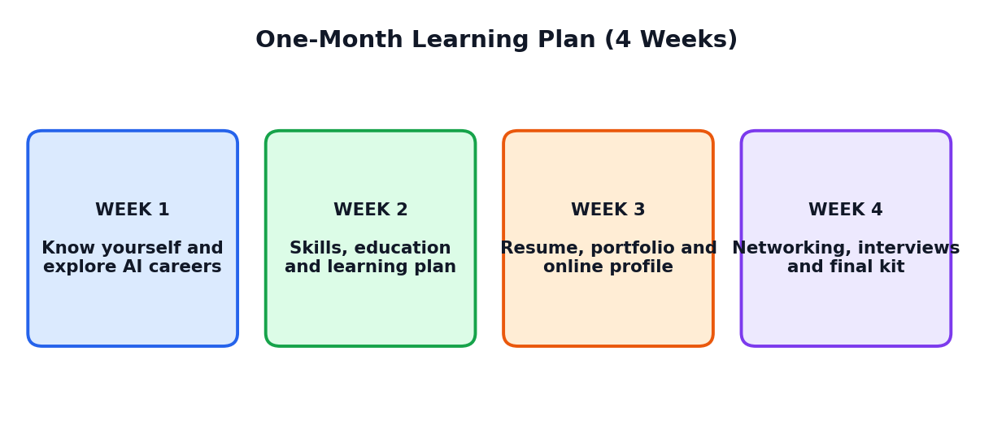
Figure 19.1: The four-week learning journey

19.1 Weekly Plan
Week | Theme | Chapters | Main activities
1 | Know yourself and explore AI careers | 1, 2, 3, 4 | Career conversation; my sweet spot; career research sheets; skills gap
2 | Skills, education and learning plan | 5, 6, 14, 15 | Pathway plan; profile audit and Profile Kit; 90-day plan; experience plan
3 | Resume, portfolio and online profile | 7, 8, 9, 11 | First resume; first portfolio project; digital footprint audit; AI-assisted, human-checked
4 | Networking, interviews, ethics and final kit | 10, 12, 13, 16, 17 | Self introduction; network map; mock interviews; code of conduct; Profile Kit presentation

19.2 Session Guide
Week | Sessions | Student tasks
1 | 1: Job and career; AI and work  2: Know yourself: interests and strengths  3: Values and skills inventory  4: Exploring AI careers  5: Skills for the AI age; quiz | Activities 1.1, 2.1, 3.1, 4.1
2 | 1: Education pathways  2: Profile: the big picture  3: Goals and 90-day plan  4: Gaining experience early  5: Review quiz | Activities 5.1, 6.1, 14.1, 15.1
3 | 1: Writing a resume  2: Building a portfolio  3: Online presence and safety  4: Using AI honestly  5: Peer review of resumes | Activities 7.1, 8.1, 9.1, 11.1
4 | 1: Personal brand and communication  2: Networking and mentors  3: Applications and interviews  4: Ethics and online safety  5: Final presentations | Activities 10.1, 12.1, 13.1, 16.1 and the Profile Kit

19.3 Assessment Ideas
Method | Marks (suggested) | What is assessed
Weekly quizzes (4) | 20 | Understanding of concepts
Launchpad File and activities | 15 | Completion and quality of work
Resume and portfolio project | 20 | Skills shown with proof
Profile Kit | 25 | Overall completeness and honesty
Presentation and mock interview | 15 | Communication and confidence
Ethics and participation | 5 | Responsible attitude

19.4 Self-Evaluation Chart
I can... | Not yet | Getting there | Confident
Explain job, career and the changing world of work
Describe my interests, strengths and values
Describe at least three AI-related careers
Write a clear one-page resume
Create a portfolio project with a case study
Protect my privacy online and spot scams
Introduce myself and answer questions using STAR
Use AI honestly to improve my profile
Make and follow a 90-day plan

Glossary and Quick Revision
Key words in simple English
Term | Meaning
Career | The long journey of a person's working life
Job | A particular piece of work done for pay
Professional profile | The complete picture of your skills, work, education and presentation, shown with proof
Sweet spot | Where interests, strengths, values and world needs meet
Skills inventory | A list of everything you can do
Human skills | Skills like communication, teamwork and empathy
Digital skills | Skills with computers, data, information and AI tools
T-shaped skills | Broad general skills plus deep skill in one area
Growth mindset | Belief that skills can grow through effort and feedback
AI literacy | Knowing what AI can and cannot do and using it wisely
Resume / CV | A short summary of education, skills, projects and activities
Portfolio | A collection of your best work with proof of skills
Case study | A short story about a project: problem, role, process, result, learning
Digital footprint | The trail of everything you do online
Personal brand | The impression people have about you
Networking | Building honest and helpful relationships
Mentor | An experienced person who guides your growth
Informational conversation | A short talk to learn about someone's work and career path
Internship | A short period of learning by working with an organisation
Volunteering | Giving time to help a cause without pay
STAR method | Situation, Task, Action, Result: a way to answer interview questions
SMART goal | Specific, Measurable, Achievable, Relevant, Time-bound goal
Plan B | A backup plan if the first plan does not work
Ethics | Principles of right and wrong
Academic honesty | Doing and presenting your own work truthfully, with credit to sources
Deepfake | A realistic fake image, voice or video made with AI
Scam | A trick to cheat people of money or information
Two-step verification | An extra security step when logging in, besides the password

One-Page Quick Revision
KNOW YOURSELF AND EXPLORE
- Job = one step; career = journey. AI is changing tasks, skills and roles.
- Sweet spot: interests, strengths, values, world needs.
- AI careers: AI-building and AI-using roles; skills: human, digital and AI, specialist (T-shape).
- Pathways: degrees, diplomas, online learning, apprenticeships; compare using a scoring table; keep Plan B.

BUILD YOUR PROFILE
- Six parts: resume, portfolio, online profile, skills list, network, personal brand.
- Claim + proof = credibility. Be honest, clear, specific, relevant, consistent, up to date, safe.
- Resume: one page; action words and numbers. Portfolio: 3 to 5 projects with case studies.
- Online: real name, clear photo, headline, about, privacy settings, safe posting.

GROW AND SHOW
- Communicate: 30-second introduction, polite emails, good listening.
- Network: mentors, informational talks, thank-you notes, give back.
- Interview: STAR method; practise with real people; handle rejection with learning.
- Plan: SMART goals, goal ladder, 90-day plan (learn, build, show).

ALWAYS REMEMBER
- Never lie in your profile; never let AI invent facts.
- Never pay for selection; never share OTPs or sensitive data.
- Use AI to learn and polish, not to replace your own effort.
- Take care of your wellbeing; ask trusted adults for help.
- Congratulations on completing the course book! Launch your journey with confidence.

